IrDA Wireless Connection
User’s Manual
1. Introduction
2. Product Features
3. System Requirements
4. Installing IrDA Wireless Connection
5. Check Driver Installation Result
6. Remove IrDA Wireless Connection
- Introduction

Thank you for purchasing our product of IrDA Wireless Connection. IrDA Wireless Connection is an easy-to-use FIR Infrared adapter, which is to be connected to the USB port of the COMPUTER to add the wireless Infrared feature to the system. Wireless File Transfers for Notebooks, Desktop PCs, Digital Cameras, Cellular Phones and more!

- Product Features

- Easily enable IrDA function on the PC through USB port
- USB Plug and Play convenience
- IrDA data rates from 2.4Kbps to 4Mbps
- Obtains power from USB port
- Uses standard IrDA transceivers
- Full compliance to IrDA 1.3 and USB 1.1 specifications
- 4Kbyte FIFO buffer memory
- Support Windows 98, Windows 98 SE, Windows Me, Windows 2000 or Windows XP

3. System Requirements

- IBM PC or compatible PC with 486DX-100 MHz CPU or higher
- Available USB port
- CD-ROM drive
- At least 16MB of DRAM

4. Installing IrDA Wireless Connection:
Follow the steps below on installing the IrDA Wireless Connection software:
1. Insert the driver CD-ROM included the “Setup.exe” file into drive on your computer.



2. Run the “Setup.exe” from the drive, and you will see a setup screen as below.
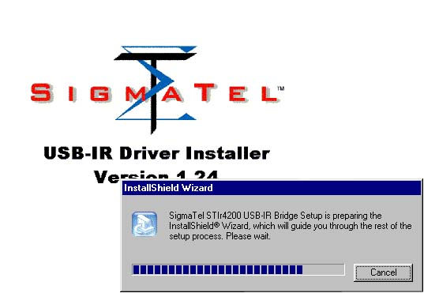
3. Click <Next> to continue installation, and you will get a new window as below.
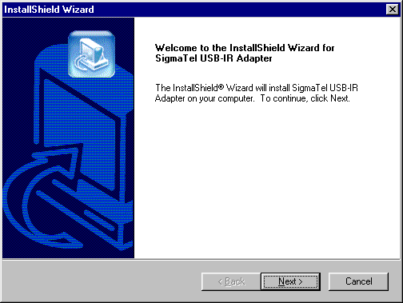
4. Click <Yes> to continue installation, and you will get a new window as below.
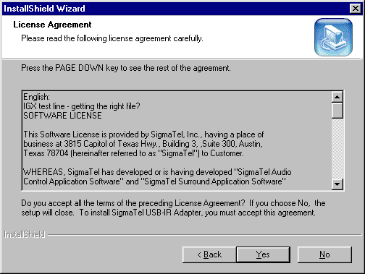
5. Click <Next> to continue installation, and you will get a new window as below.
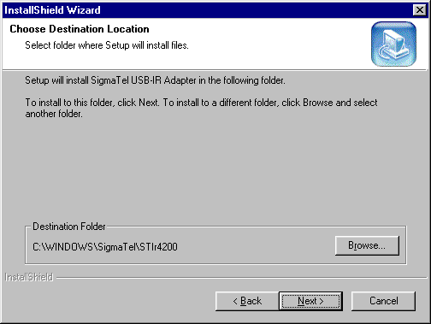

6. Let Windows copy the needed files to your hard disk.
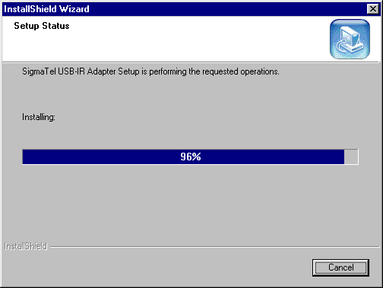

7.Click “Finish”, and you will get a new window as below.

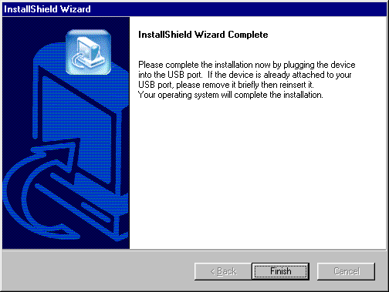

8. It will get a windows as below, please connect the IrDA Wireless Connection to the Computer's USB PORT

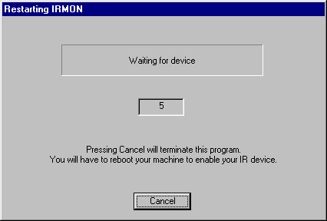

9. Computer will checking the IrDA Wireless Connection & starts to install the driver automatic. (If it's the first time for your computer to install it, the computer will have a reminder " Please insert the disk Labeled " Windows 98 Second Edition CD-ROM".) And then click "OK”.

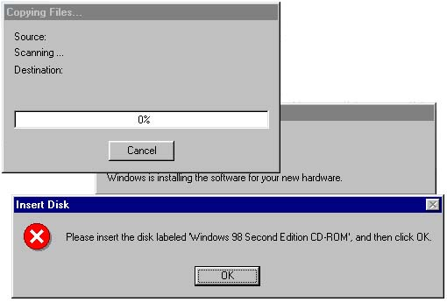

10. Please select the position of the Windows 98 Second Edition. And then click " OK " .
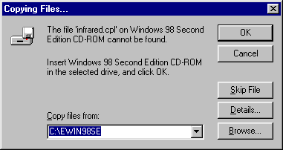

11. Let Windows copy the needed files to your hard disk.
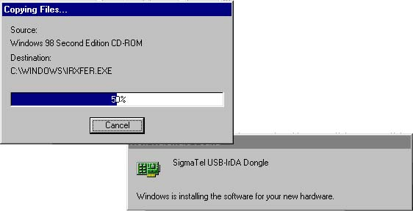

12. Remove any disk from the CD-ROM, Then click " Finish" to complete setup & Restart your computer.

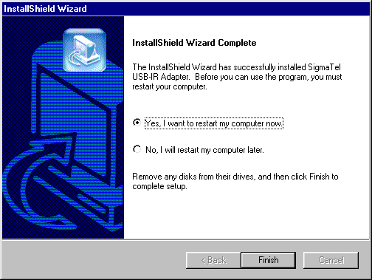

Check Driver Installation Result

- Move the course on “My Computer” icon as below. double-click the icon for open “My Computer",you will see “Infrared Recipient”; and then One click the right button of mouse and a pull-down window appears. Select the latest item-“Properties”.

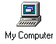

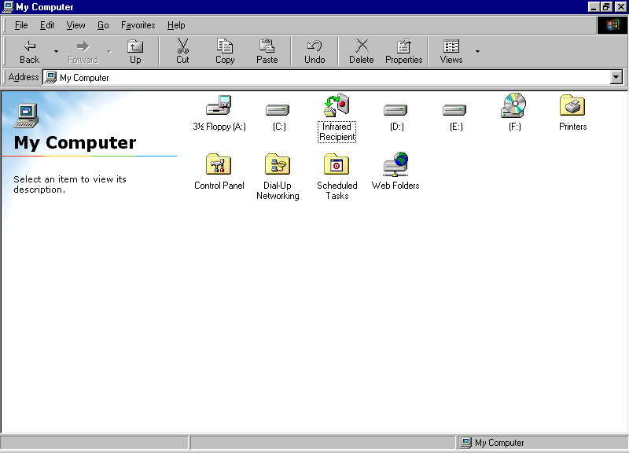

2. Enter system properties, choose the “Device Manager” from the table. You will see the system devices arranged by type as below.

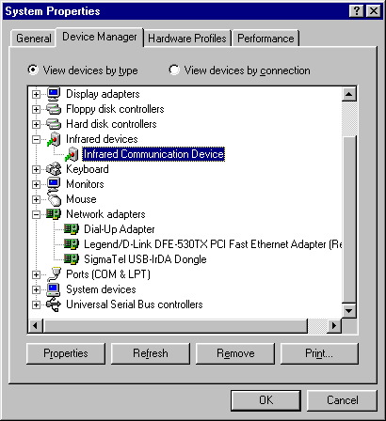

3. Plug IrDA Wireless Connection into computer. You will get a new device under the “Infrared devices” category, who is “Infrared Communication Device” as below.
In addition, you can see a Network driver, “SigmaTel USB-IrDA Dongle” be hooked under “Network adapters” category. This item is always there regardless of the dongle.

Remove IrDA Wireless Connection :

1. Pull out the IrDA Wireless Connection from the computer at firstly.
- Secondly, Double click " Add/Remove Programs Properties " from the Control Panel. Pleases select " Sigmatel USB-IR Adapter" from the Install / Uninstall ". And then, please click " Add/Remove "

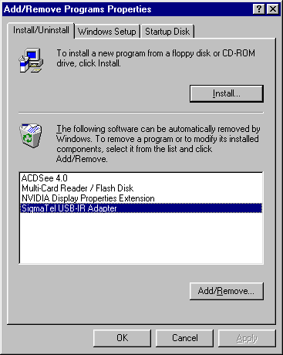

- Click “Yes” to uninstall the SigmaTel USB-IR Adapter.

