USB 6 IN 1 Card Reader
User’s Manual
- Introduction
- Product Features
- System Requirements
- Installing USB 6 in 1 Card Reader
- Remove USB 6 in 1 Card Reader

1. Introduction
This 6 in 1 combo PC Card Reader is a powerful & multi-functional device among all the other available drives, for it’s able to access most of the flash cards including : Compact Flash﹑Micro Drive﹑Secure Digital﹑Smart Media﹑Memory Stick﹑Multi Media and Built-in Flash Disk(Optional,16~128MB).
2. Product Features
※ Flash Card support: Compact Flash, Microdrive, Smart Media, Multi Media,
Secure Digital, and Memory Stick.
※ Built-in Flash Disk: 16 MB ~ 128MB (Optional).
※ USB 1.1 compatible.
※ O/S supported: Windows 98, 98SE, 2000, ME, and XP, and Mac 8.6 or above.
※ Mass Storage Class compatible.
※ Driver free for Windows ME, XP.
※ Embedded USB cable inside Card Reader, suitable for Notebook.
3. System Requirements

- IBM PC or compatible PC with 486DX-100 MHz CPU or higher
- Available USB port
- CD-ROM drive
- At least 16MB of DRAM

4. Installing USB 6 in 1 Card Reader:
Follow the steps below on installing the USB 6 in 1 Card Reader software:
1.Power on your computer and make sure that the USB port is enabled and working properly.
2. Please do not connected the USB 6 in 1 Card Reader with the computer when you it's on installing .
3. Please double click " setup.exe, then it's will get the installation interface .
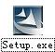
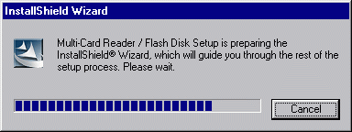

4. Click ‘Next’.

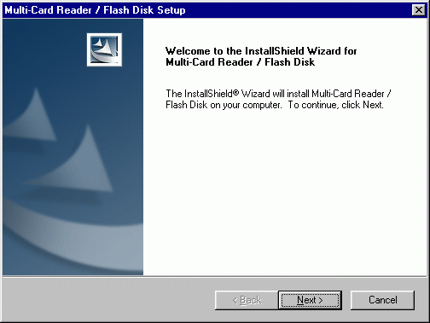

5. Click ‘Next’ .

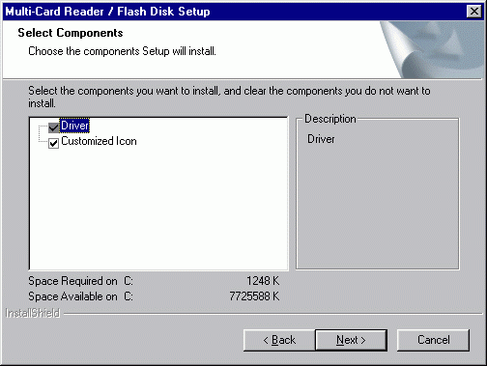

6. Let Windows copy the needed files to your hard disk.

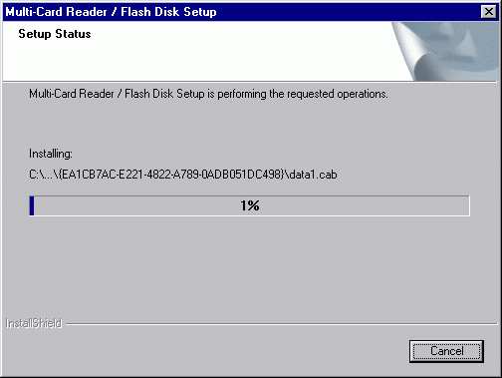

7. Installation was finished.. Click " Finish " and restart computer.

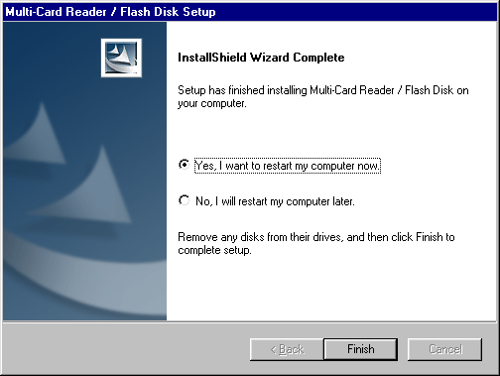

8. After restart the computer, please connected the USB 6 in 1 Card Reader with USB Port of the Computer , It's will checking & installing automatic (If it's your first time to install it, The computer will get a reminder " You need the install disk of Windows 98 " .
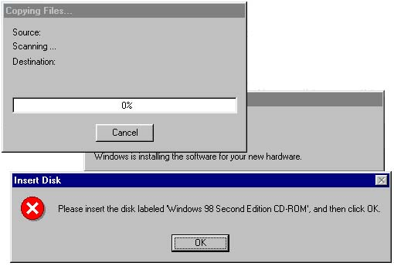

9. Installation was finished.. You can find "Multi-Card Reader 6 in 1 " & USB Mass Storage disk Driver " following the route of : System Properties / Device Manager /Universal Serial Bus Controllers " . When you see the Single "CF" "MS" SD/MMC ""FLA/SH" … from "my computer “. Congratulation!! You are successful.
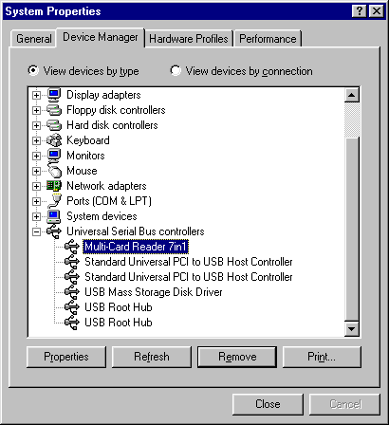
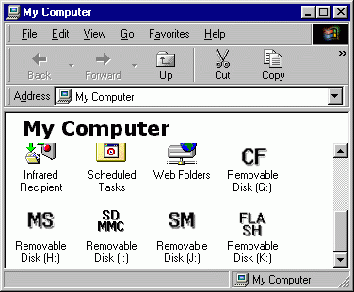

5. Remove USB 6 in 1 Card Reader :

- Firstly, Pull out the USB 6 in 1 Card Reader from the USB PORT.
- And then, double-click ”Add/Remove Programs Properties” in the “control panel” , select ” Multi-Card Reader/Flash Disk ” in the ”Install/Uninstall”, Click the below of right corner ”Add/Remove”.

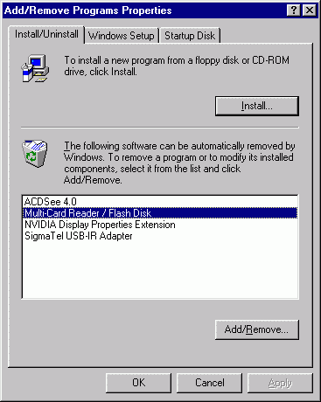
3. Select “Remove”, and then Click “Next”.
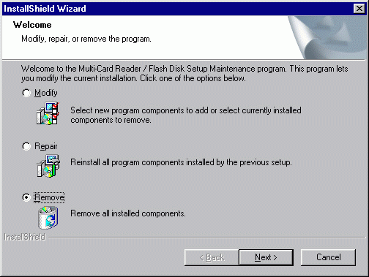
4. Click “ok”.

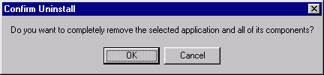
5. Click “Finish”, restart the computer. Was Finished remove.
