USB CF Card Reader
User’s Manual
- Introduction
- Product Features
- System Requirements
- Installing USB CF Card Reader
- Safely Exit USB CF Card Reader
- Remove USB CF Card Reader

1. Introduction
USB Card Reader/Writer allows you to easily transfer pictures or information to and from your Compact
Flash card to other devices, such as digital cameras ,desktops or laptops at USB speeds.
2. Product Features
- Compatible with Win98/SE/ME/2000/XP and iMac OS 8.6 or above
- Read and write any files for PC or iMac
- Plug and Play for Compact Flash card
- Easy to install , perfect for mobile user
- No external power supply needed
- No driver necessary for Win ME/2000/XP/iMac
3. System Requirements

- IBM PC or compatible PC with 486DX-100 MHz CPU or higher
- Available USB port
- CD-ROM drive
- At least 16MB of DRAM
4. Installing USB CF Card Reader:
Follow the steps below on installing the USB CF Card Reader software:
1. Power on your computer and make sure that the USB port is enabled and working properly.
2. Please do not connect the USB CF Card Reader with the computer when you it's on installing.
3. Please double click and open the folder “USB 1.1 CF CARD READER” in the CD-ROM.

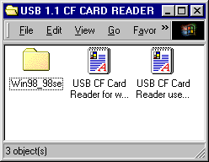

- Please double click and open the folder “ Win98_98se ”

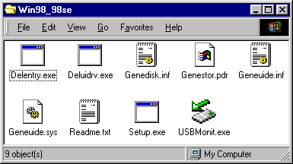

- Please double click” Setup”.Windows will copy the needed files to your hard disk .There will appear a following dialog box while finished.

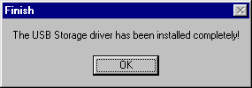

6. At this time ,please plug the USB CF Card Reader into your computer .Windows will detect and install it automatically .When finished ,you can see four disk icons in “My Computer ” as below.

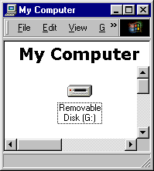

7. Follow the steps :right click “My Computer” at desktop ,appear a pup-up menu, select “Properties”, display “System Properties”, click “Device Manager”, you can see “ USB Card Reader ”in “Universal Serial Bus controllers ”,Thus, it mean you install the USB CF Card Reader successfully l.
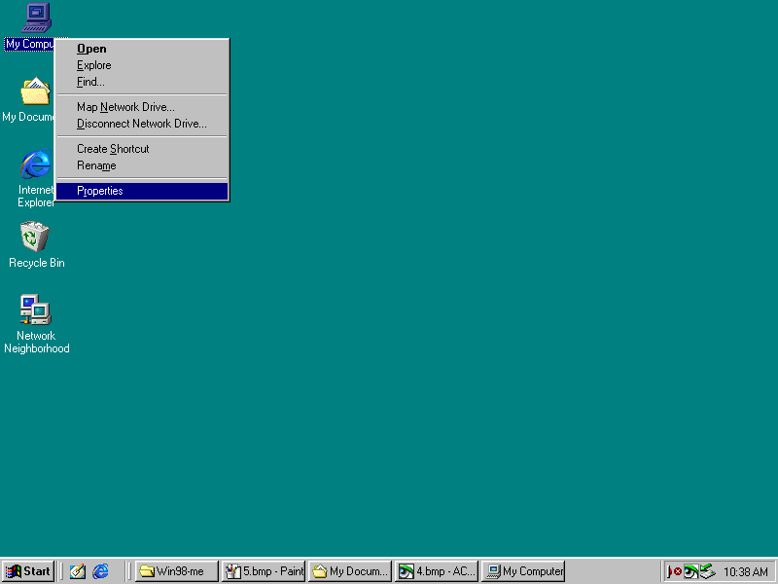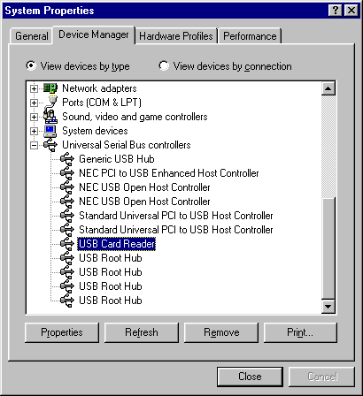
5. Safely Exit USB CF Card Reader

If you didn’t find an arrowheaded icon at right corner in system status bar, please double click “USBMonit” in the folder “Win98_98se ”, there will appear an arrowheaded icon at right corner in system status bar. When you want to unplug the USB CF Card Reader from your computer, please right click the icon and click “Stop USB Card Reader ”,then you can unplug it .

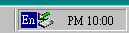
Arrowheaded icon
Double click

click
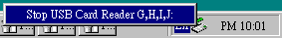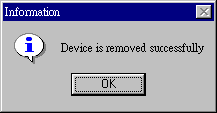
Right click

- Remove USB CF Card Reader :

1. Please double click “deluidrv.exe” in the folder “Win98_98se”.
Double click

- There will appear a dialog as below, please click “Yes”.

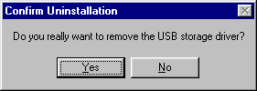

- When the following dialog box displayed, it mean you have uninstalled the USB CF Card Reader driver successfully.

