USB Electronic Hard Disk
User’s Manual

- Introduction
- Product Features
- System Requirements
- Function
- How to use
- Installing USB Electronic Hard Disk
- Remove USB Electronic Hard Disk
- FAQ

1. Introduction
USB Electronic Hard Disk is a mini-movable electronic hard disk with the storage media of flash memory. Data transferring between your PC and USB Electronic Hard Disk can be accomplished via the USB port. It has the ability to store data for a prolonged period of time by a safe way. It's anti-shock capability and water proof together with resistance to boot sector virus and high speed make this device the ideal accessory for mobile office of data storage.
Floppy disk will be replaced by the high capacity memorizer at last, the birth of USB Electronic Hard Disk shows that the age is coming. USB Electronic Hard Disk is very easy to use, do not need special technology, just plug and play. USB Electronic Hard Disk is light in weight, compact but carries a high storage, which ranges from 32MB to 1G. Data transferring between your PC and USB Electronic Hard Disk can be accomplished via the USB port without additional equipment.
It's anti-shock, magetic and water proof together with resistance to fluctuating environmental conditions make this device the ideal accessory for mobile office of data storage. It has the ability to store data for a prolonged period of time, for about ten years long, you can write and read for about one million times.
2. Product Features
- No physical drive required, no external power supply required.
- Capacity: 32MB, 64MB, 128MB, 256MB,1G USB interface, hot PnP
- Small, compact, easy carry and suitable for storage exchange
- Can be re-written for at least one million times, data can be saved for minimum 10 years
- Secure, written protection function
- Shockproof, magnetization resistance; Can work under temperature range -40oC~70oC
- Windows98/SE/ME/2000/XP, Mac OS 9.X/Mac OS X, Linux 2.4 etc
- Only in Windows 98/SE system need to install driving program
3. System Requirements

- IBM PC or compatible PC with 486DX-100 MHz CPU or higher
- Available USB port
- CD-ROM drive
- At least 16MB of DRAM

4. Function
1.Write-Protect 2. Security function 3. Primary format 4. USB Startup
1. The Security Function of Software
USB Pen Driver already have the function of Security at the beginning , the Primary password is "0000".There are 2 section , one is public section and the other is security section. It's only 3MB capacity for the public Section. and the rest capacity is for security section. So the Write-Protect is workable in the security section. Please change the password at firstly.Step as follows:
a.) Please contact the USB Pen Driver with the computer. And it will come out a frame ask for insert the password.( When it's you first Time to use, pleas double clike "FDSECU.EXE "file which under public section, and them It will come out a frame ask for insert the password.)
b.) Please click " Setting " , and it will come out enactment plane.please click " Change Password ", and then insert the new password what you want.
C.) Please bear in mind the new password.
2. Write Protect
5. How to use
a.) Can be write-read : Put the Write-Protect button up
b.) Only can be read : Put the Write-Protect button down
3. Double startup for USB-ZIP & USB-FDD
Notice: The user's BIOS of mainboard must be support the startup for USB-ZIP & USB-FDD.
Utility Step
a.) Please contact the USB Pen Driver with computer.
b.) When the computer is on startup,please come into COMS and make the first device as the USB-ZIP or USB-FDD
c.) Save the device and re-startup the computer.
4. Primary Format
1. Please open "Flash Disk MP Tool(R1.1.4)", and then click the button of "Step Run" for "Step Run" panel
2. After that please click " Low Level Format" to make the Primary Format.
Notice:
1. The Primary Format will clean out all date of USB Pen Driver, it will including password, security section & public section.
2. Primary Format can be worked under the Win2000, but Win98 & Me can't Be support Primary Format.
- After you see the file of "System Properties" / Device Manager/Universal Serial Bus controllers/USB Mass Storage Disk Driver ", please start primary format.
6. Installing USB Electronic Hard Disk:
Follow the steps below on installing the USB Electronic Hard Disk software:
1.Power on your computer and make sure that the USB port is enabled and working properly.
2. Please do not connected the USB Electronic Hard Disk with the computer when you it's on installing.
3. Please double click " setup .exe " Then, it will get the interface of installation.
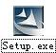
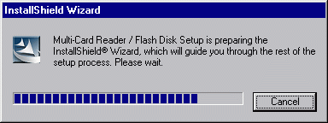

4. Click ‘Next’.

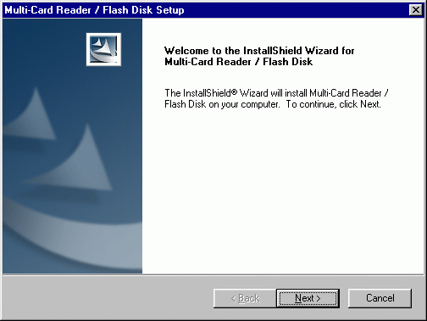
5. Click ‘Next’ .
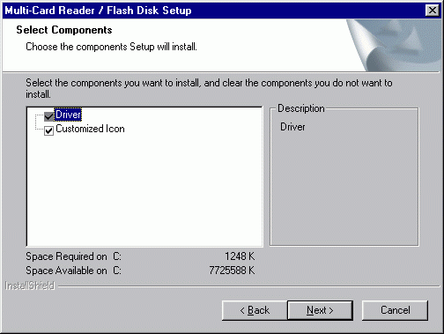
6. Let Windows copy the needed files to your hard disk.

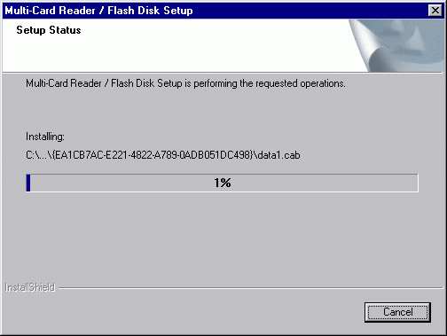
7. Installation was finished. Click " Finish " and restart computer.
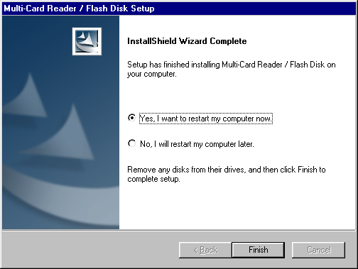
8. After restart the computer, please connected the USB Electronic Hard Disk to the USB Port of the Computer, It's will checking & installing automatic (If it’s your first time to install it, The computer will get a reminder " You need the install disk of Windows 98 ” ).
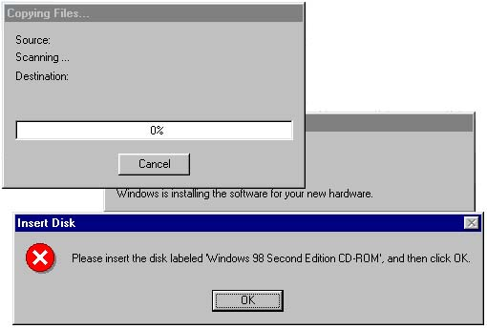

9. Installation was finished. You can find “USB Mass Storage Disk Driver " following the route of : “System Properties” → “Device Manager” → “Universal Serial Bus Controllers”. When you see the Single "SM" from "my computer “. Congratulation!! You are successful.
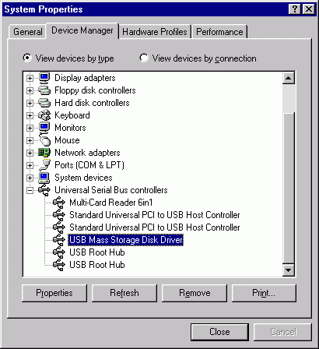

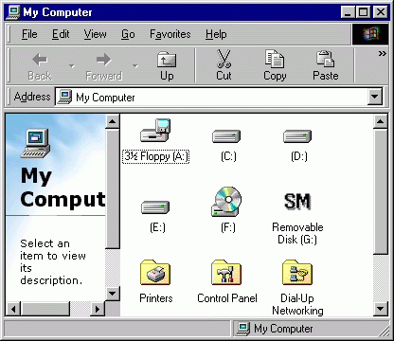

7. Remove USB Electronic Hard Disk :

- Pull out the USB Electronic Hard Disk from the USB PORT .
- And then double-click ”Add/Remove Programs Properties” in the “control panel” , select ” Multi-Card Reader/Flash Disk ” in the ”Install/Uninstall”, Click the below of right corner ”Add/Remove”.

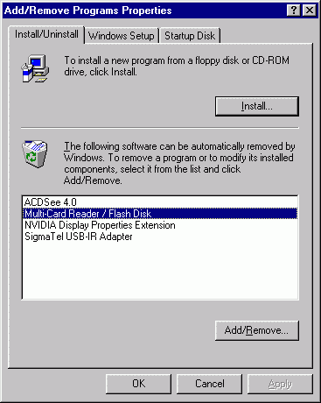
3. Select “Remove”, and then Click “Next”.
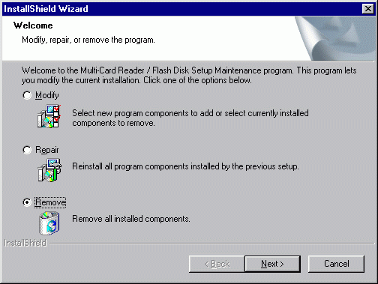
4. Click “ok”.

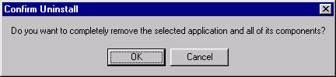
5. Click “Finish”, restart the computer. Was finished remove.
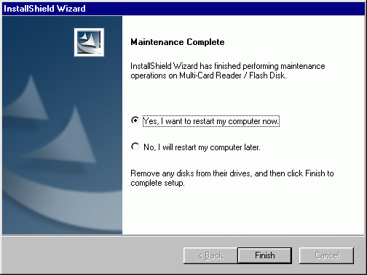

FAQ
- What USB Electronic Hard Disk memory sizes are available?
USB Electronic Hard Disk are currently available in 32,64,128,256MB and 1G capacities. Larger capacities will be available in the future.

- Which operating system can USB Electronic Hard Disk operate on?
USB Electronic Hard Disk can be operated on any of the following OS. Windows 98, Windows 98 SE, Windows ME, Windows 2000, Windows XP, Mac or above and Linux 2.4.0 or above.

- What kind of data can be stored on USB Electronic Hard Disk?
You can save any type of files on USB Electronic Hard Disk. Whether they are text, graphic, program, music or multimedia files.

- Do I need to turn my computer off when installing USB Electronic Hard Disk?
No, USB Electronic Hard Disk is a hot plug and play device. You can install USB Electronic Hard Disk anytime you want, even with the computer on.

- Is it safe to remove USB Electronic Hard Disk while files is being transferred?
No, when the light is flashing it means data transfer is taking place, do not remove USB Electronic Hard Disk as it may result in lost of file/data, or even damage USB Electronic Hard Disk.

- Can the data on USB Electronic Hard Disk be shared in a networking environment?
Yes, the data can be shared in a networking environment, as long as the host machine enables the share function for USB Electronic Hard Disk.

- Can USB Electronic Hard Disk be formatted? How?
Yes, USB Electronic Hard Disk can be formatted under Windows 98, Windows ME and Windows 2000,using normal formatting function.

- Can USB Electronic Hard Disk be used under DOS environment?
No, because DOS does not support USB devices , so USB Electronic Hard Disk cannot be used under DOS environment.

- What operating systems will USB Electronic Hard Disk not support?
USB Electronic Hard Disk will not support Windows 95 or Windows NT, since both these operating systems does not support USB devices.

- Can USB Electronic Hard Disk work in Windows NT?
No. Since Windows NT does not support USB devices, therefore, USB Electronic Hard Disk cannot work under Windows NT environment.

