USB TO Link Cable
User’s Manual
- Introduction
- Product Features
- System Requirements
- Installing USB TO Link Cable
- application in practice
- Remove USB TO Link Cable

1. Introduction
The USB Network Link cable provides a quick and easy solution to network up to 17 USB computers via hot Plug & Play technology without adding any Network Interface Cards. It is suitable for small offices, home offices, mobile users, and network gamers. With the USB Network Link cable, users can play multi-player games, share files, printers, peripheral equipment, and more.
The USB Network Link cable is your fast solution to peer-to-peer file transfer between two computers via the USB port. The USB Network Link cable provides true plug-n-play capability while transferring files at much greater speed than traditional file transfer products via serial or parallel port, more than 6M bits/sec can be achieved. In most applications, the user will get greater than 4M bits/sec of smooth file transfer rate. The USB Network Link Cable application program, a Windows Program Manager-like user interface, provides a very easy to use environment that makes file transfer as easy as drag-and-drop. You simply plug in the USB Network Link Cable and do a one-time installation of the program.
2. Product Features
- Maximum Data transfer rate: Over 5 Mbps
- Single cable solution for network communication
- Single cable solution for data communication
- Windows 98/Me/2000/XP Support
- Easy drag-n-drop file transfer
- Standard Windows Explorer user interface
- Support TCP/IP, NetBEUI, IPX/SPX protocols
- Full NDIS driver implementation
- No external power needed
- Compliant with USB specification 1.1
- Multiple file selection can be synchronized
- Sub-directory files can be synchronized
- Hot PnP for easy use
- Suitable for SOHO and mobile network environment
3. System Requirements

- IBM PC or compatible PC with 486DX-100 MHz CPU or higher
- Available USB port
- CD-ROM drive
- At least 16MB of DRAM
4. Installing USB TO Link Cable :
Follow the steps below on installing the USB TO Link Cable software:
- Power on your computer and make sure that the USB port is enabled and working properly.
2. Please double click "setup.exe" to get " image 1 ".
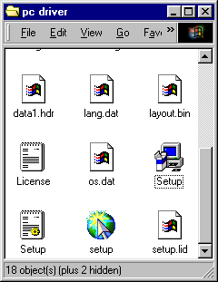

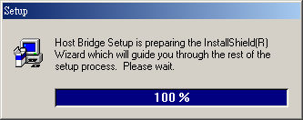
image 1

3. Please click " Next " continue to install.
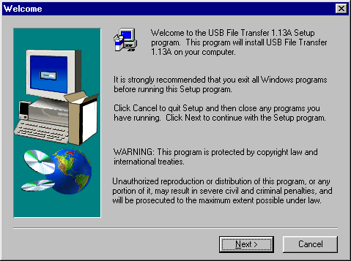
4. Please click " Yes" to continue installing.
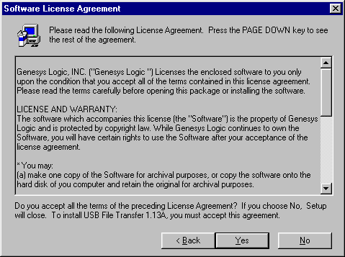

5. If it's installed to a different folder, Please click Browse and select another folder. Then click
" Next " to continue installing.
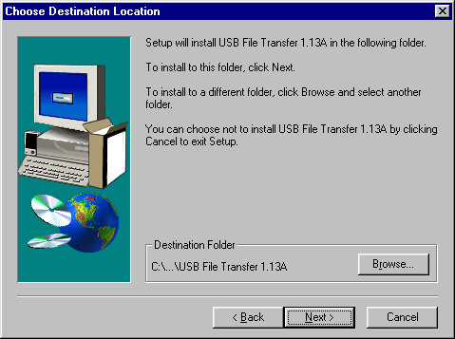
6. After windows copy the needed files to the system, it will get the following interface. Then, Please
connect the USB Link Cable to the USB PORT of the computer, And click " Finish " It's will install the USB Link Cable automatic.
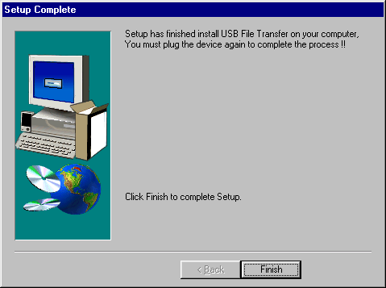

7. It will show following icon .
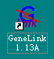
8. Move the course on “My Computer” icon as below. Double-click the icon to open “My
Computer”, you will see “ Removable ”; and then click the right button of mouse and a pull-down window appears. Select the latest item-“Properties”.
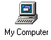
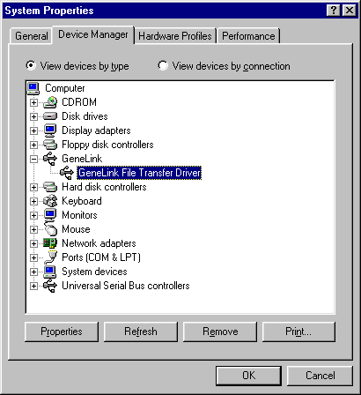

application in practice:
- Please double click "GeneLink 1.13A" which on the desk up to get "image 2 " .
- It means having not been connected. (Image 2)
- It means being on connection. (Image 3)
- It means being connected. Meanwhile, the " Remote Desktop " on the right will display the other
computer’s catalogue. (image 4 )
- Select the folder & file which should be copy, then click or or to copy the folder & file to the corresponding computer.

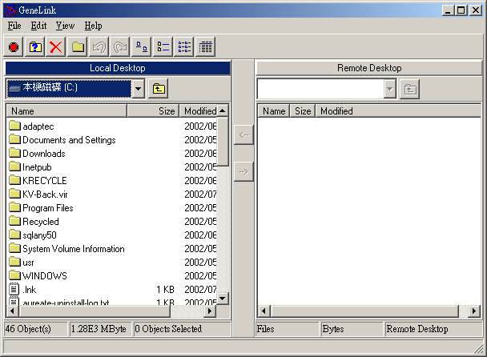
1
image 2
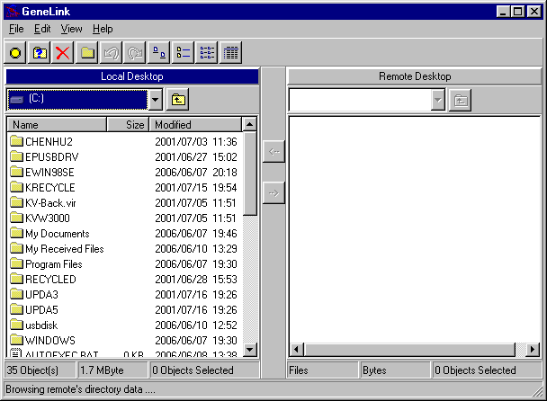
2
image 3
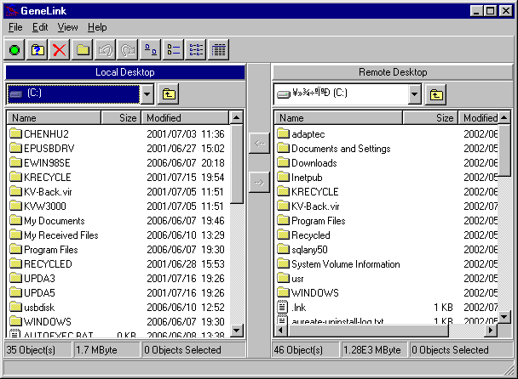
3
image 4
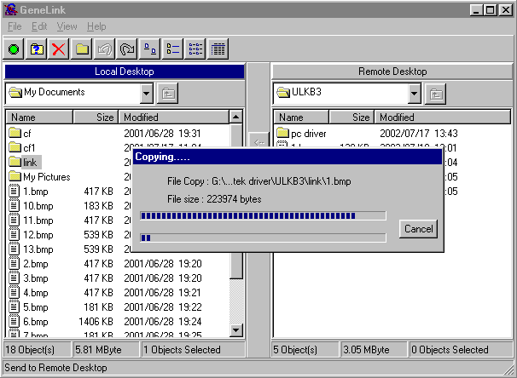

image 5
Remove USB To Link Cable

- Firstly, Please pull out the USB Link Cable from the USB Port .
- Please open the " Control Panel " ;Then double click " Add/Remove Programs " up to get Image 6 .
- Please select " USB File Transfer 1.13A" , and click " Add/Remove " on the right . Then remove USB Link Cable .

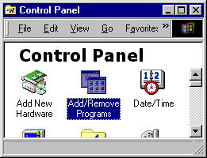
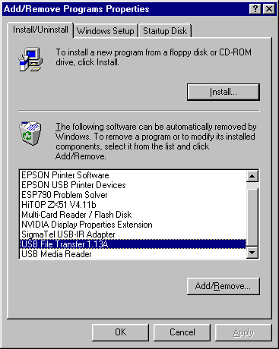
image 6

