USB MMC/SD Card Reader
User’s Manual

- Brief Introduction
- Product Features
- System Requirement
- Install USB MMC/SD Card Reader
- Uninstall USB MMC/SD Card Reader

1. Brief Introduction

Flash card memory series is the best reader/writer device in the world. You can save musics、images、files in flash card or transmit these data which saved in flash card to your computer through the USB card reader at any moment.

2. Product Features
※ support hot-swap, plug and play, Compliant to USB 1.1
※ Flash Card support: Multi Media card, Secure Digital card
※ Suitable for related products of Sony
※ small and exquisite, easy to carry in your pocket
※ support Windows 98, 98SE, 2000, ME, and XP, Mac os 8.6 or higher
※ Only window 98/98SE need driver
3. System Requirement

- IBM PC or compatible PC with 486DX-100 MHz CPU or higher
- Available USB port
- CD-ROM drive
- At least 16MB of DRAM

4. Install USB MMC/SD Card Reader
Please follow the steps below to install the USB card reader driver:
1. Power on your computer and make sure that the USB port is enabled and working properly.
2. Please do not connect the USB MMC/SD Card Reader with the computer when you it's on installing.
3. Please double click “setup.exe ", then it does will get the installation interface.
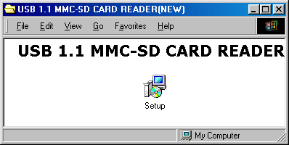
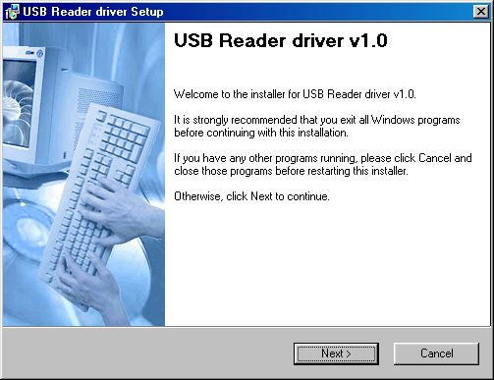

4. If you want to change the installation directory, please click “Change” to change the directory, and then click “Next” to continue to install.

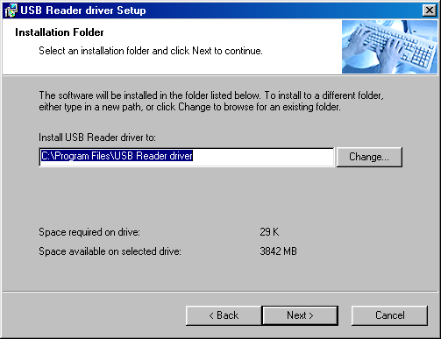

5. Please click "Next” to continue.

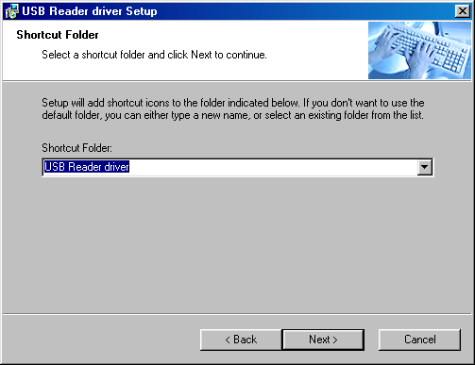

6. Please click "Next” to continue, Windows will copy the needful files to your hard disk.

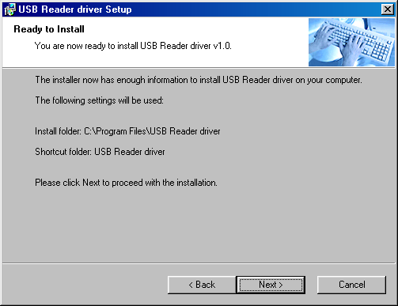

7. When installation completely, please click" Finish ", then reboot your computer.

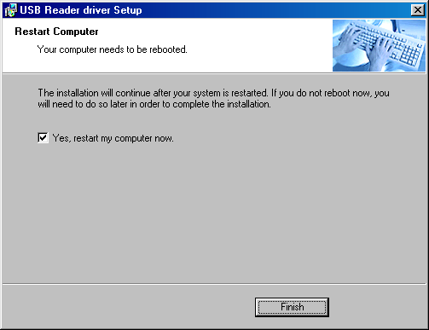

8. When reboot your computer again, please plug the USB MMC/SD card reader into the USB port of your computer. Windows will detect and install it automatically.

9. When installation finished. Please follow the steps “System Properties”-> “Device Manager”->” Disk drives ", you can see "Generic USB SD Reader"; you can see “USB Storage” in “Storage device”; you can see “Generic USB SD Reader” in “Universal Serial Bus controllers”. When you see “Removable Disk” icon in “My Computer”. Congratulates! You are successful!
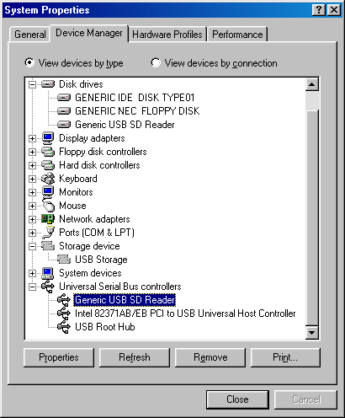
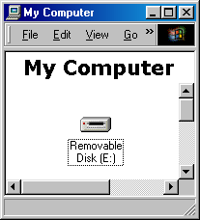

5. Uninstall USB MMC/SD Card Reader

- First at all, unplug the USB MMC/SD card reader from the USB port of your computer.
- Then, please follow the steps “ Start”->” Programs”->” USB Reader driver", click “Uninstall USB Reader driver v1.0” to start to uninstall.
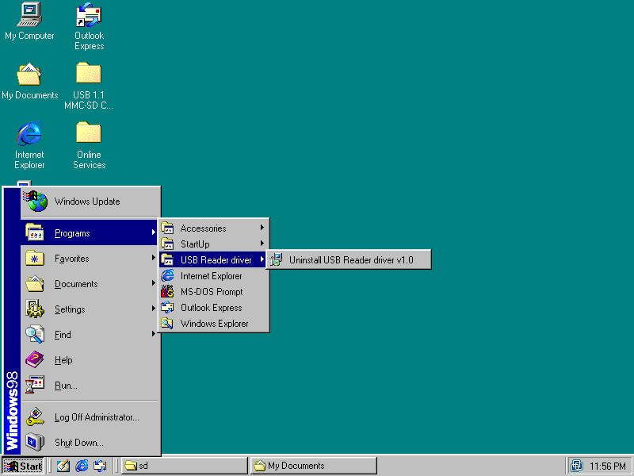
3. Select “Remove“, then click “Next“.
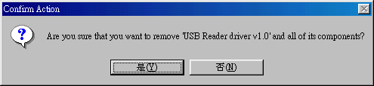
4. Please click "Close“ to reboot your computer, and then you will uninstall the USB MMC/SD card reader completely.
