USB MMC/SD Card Reader
User’s Manual
- Introduction
- Product Features
- System Requirements
- Installing USB MMC/SD Card Reader
- Remove USB MMC/SD Card Reader

1. Introduction
Travel Flash Series are the only Readers/Writers in the world. You can store your data in the Travel Flash readers/writers anytime, anywhere even without any Flash Card on hand.Travel Flash readers/writers offer the most convenient method to move and store the music, images and data.
2. Product Features
※ Hot-Swappable Supported, Compliant to USB 1.1
※ Flash Card Support : Multimedia Card and Secure Digital Cards
※ Suitable for related products of Sony
※ Easy to carry in your pocket
※ support Windows 98, 98SE, 2000, ME, and XP, and Mac 8.6 or above.
※ Only window 98,98SE need driver
3. System Requirements

- IBM PC or compatible PC with 486DX-100 MHz CPU or higher
- Available USB port
- CD-ROM drive
- At least 16MB of DRAM

4. Installing USB MMC/SD Card Reader:
Follow the steps below on installing the USB MMC/SD Card Reader software:
1.Power on your computer and make sure that the USB port is enabled and working properly.
2. Please do not connected the USB MMC/SD Card Reader with the computer when you it's on installing .
3. Please double click " setup.exe ", then its will get the installation interface.
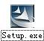
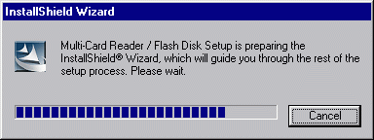

4. Click ‘Next’.

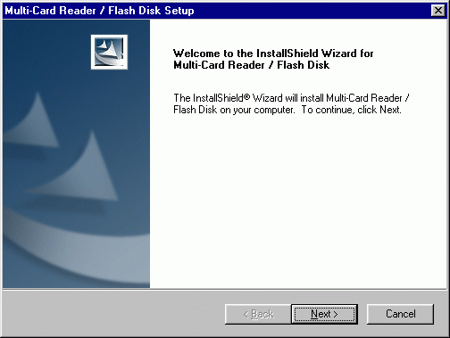

5. Click ‘Next’ .

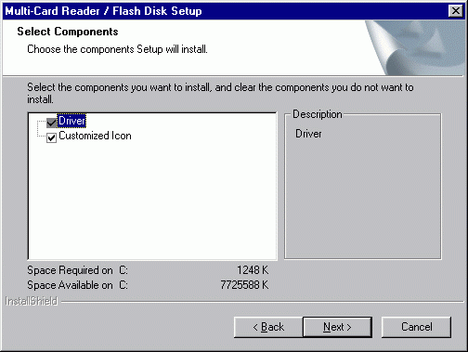

6. Let Windows copy the needed files to your hard disk.

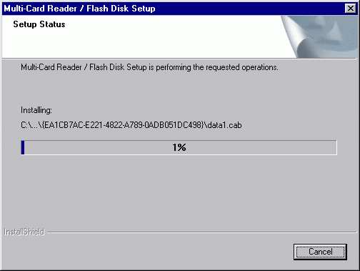

7. Installation was finished.. Click " Finish " and restart computer.

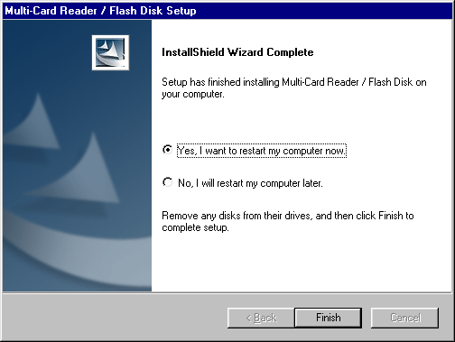

8. After restart the computer, please connected the USB MMC/SD Card Reader with USB Port of the Computer , It's will checking & installing automatic (If it's your first time to install it, The computer will get a reminder " You need the install disk of Windows 98 " .
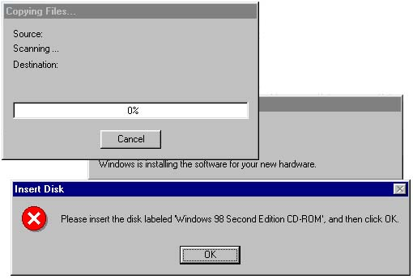

9. Installation was finished.. You can find "Multi-Card Reader 6 in 1 " & "USB Mass Storage disk Driver " following the route of : System Properties / Device Manager /Universal Serial Bus Controllers " . When you see the Single " Removable Disk " from "my computer “. Congratulation!! You are successful.
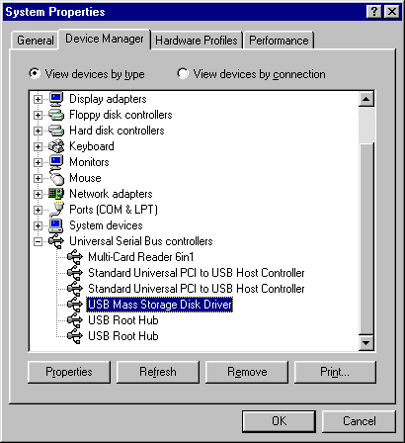
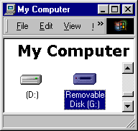

5. Remove USB MMC/SD Card Reader :

- Firstly, Pull out the USB MMC/SD Card Reader from the USB PORT.
- And then, double-click ”Add/Remove Programs Properties” in the “control panel” , select ” Multi-Card Reader/Flash Disk ” in the ”Install/Uninstall”, Click the below of right corner ”Add/Remove”.

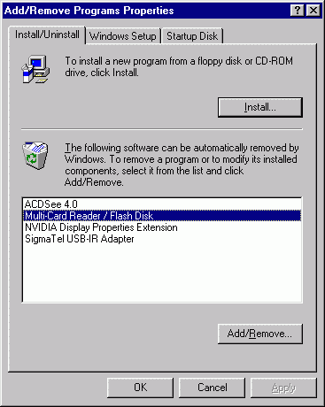
3. Select “Remove”, and then Click “Next”.
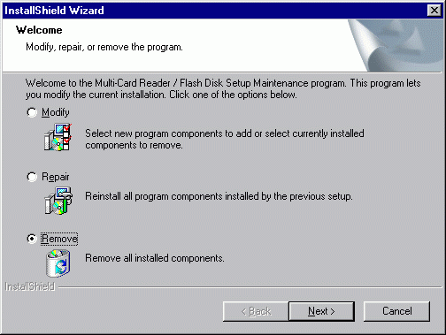
4. Click “ok”.

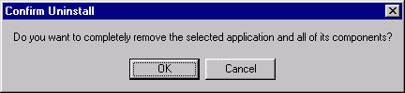
5. Click “Finish”, restart the computer. Was Finished remove.
