USB TO Network Cable
User’s Manual

1. Overview
2. Functions
3. Install GeneLink Driver
4. Macintosh To Macintosh file sharing
5. Internet sharing between PC and Macintosh

Overview
GeneLink™ provides the easiest network connection service to you. By connecting two Macintosh machines through GeneLink™ , you can build up a direct network connection without any network adapter Furthermore, GeneLink™ gives you the ability of connecting Macintosh to your PC for the Internet sharing.

Functions
GeneLink™ works the same function with the Ethernet card. By binding the suitable protocol such as Apple Talk or TCP/IP to GeneLink™ , one Macintosh can share its resource to the other.Two or more PCs can connect through GeneLink™ to build up a local area network. This is not the same condition to Macintosh. GeneLink™ can only connect two Macintosh machines. You cannot connect three or more Macintosh machines by GeneLink™.
Besides, GeneLink™ doesn support the software router for Macintosh. One Macintosh cannot connect to Internet or another LAN through the other Macintosh.
Mac A cannot connect to Internet or the other LAN through Mac C
LAN or Internet
Only one GeneLink connection support in Macintosh
Mac B
Network Cable
Mac C
Mac A
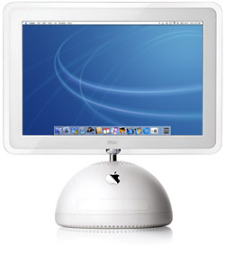

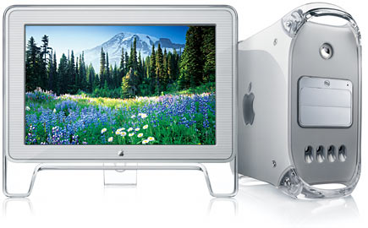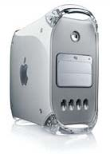

PC can provide the Internet sharing service to Macintosh if the Windows software router is installed. GeneLink™ doesn’t provide the file sharing service between PC and Macintosh except the suitable third party software is installed.
Notebook
PC
Software router is installed
Internet
Macintosh can connect to Internet through PC
Macintosh

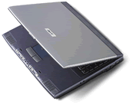
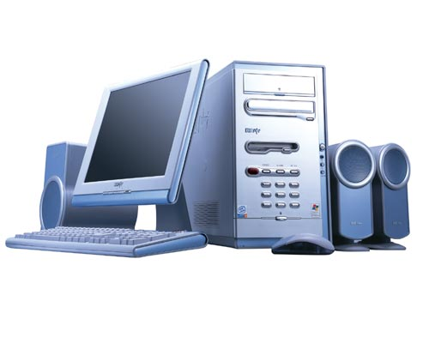

Install GeneLink™ Driver
GeneLink™ driver installation procedure is divided into the following steps.
1. Insert GeneLink™ setup diskette.
2. Run USB Net Installer.
3. Restart the system.
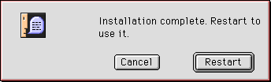

4. Plug in the GeneLink™ cable.

Macintosh-To-Macintosh file sharing
GeneLink™ provides the easiest Mac-to-Mac network connection. The network setting of the file sharing can be explained from the server side and the client side. The computer sharing its resources to others is defined as the server side. The computer accessing the other’s resource is defined as the client side.
Server Side Setting
In the server side, the file server should be enabled so that the files can be shared. After the file server is turned on, the computer name will occur in the file server list of other Mac. Turn on the file server by the following steps.
1. Select ‘Control Panels’ / ‘AppleTalk’ from the system menu.
2. Choose connect-via “USB-Port1”. Please make sure GeneLink™ cable has been plug in at this time. Otherwise, “USB-Port1” is not displayed in the select list.

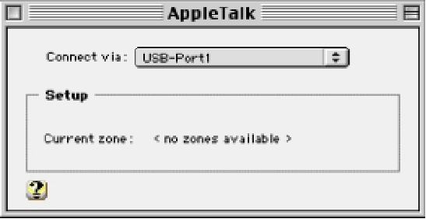

3. Close the AppleTalk dialog box and save the setting.
4. Select ‘Control Panels’ / ‘File Sharing’ from the system menu.

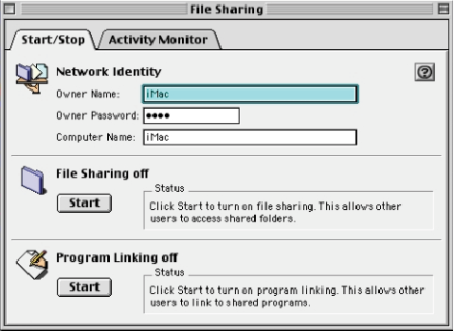

5. Choose ‘Start/Stop’ Tab.
6. Press ‘Start’ button to turn File Sharing on.
After the file server is turned on, the other computer can login this computer for file access.The other computer can login the file server via the registered user account or guest. The server side should create the new user account or enable the guest login for the client side. The dialog box of these settings is located in the different position between Mac OS 8.5/8.6 and Mac OS 9. For Mac OS 8.5/8.6, select ‘Control Panels’ / ‘Users & Groups’ from the system menu. For Mac OS 9,select ‘Control Panels’ / ‘File Sharing’ and choose ‘Users & Group’ tab. After the Users & Groups dialog box is displayed, press ‘New User’ or ‘New Group’ to create the new account. To allow the client side to login as guest, please do the following steps.
1. Open the guest account in the Users & Groups dialog box.
2. Select “Sharing” from the show list.
3. Click the check box next to “Allow guests to connect to this computer” to the checked status.

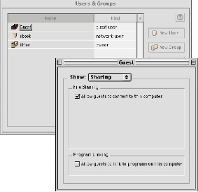

To make the folder visible to the other computer, the access privilege of the folder needs to be set. Set the file folder access privilege by the following steps.
1. Select the file folder to be shared.
2. Select ‘File’ / ‘Get Info’ / ‘Sharing’ from the system menu.

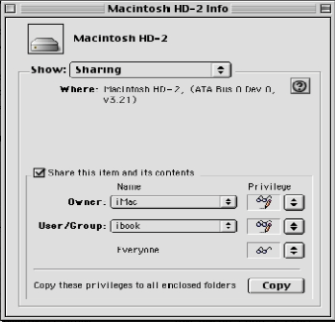

3. Click the check box next to “Share this item and its contents” to the checked status.
4. Set the access privilege for the owner, user/group, everyone.
Client Side Setting
In the client side, make sure the protocol is setup correctly.
1. Select ‘Control Panels’ / ‘AppleTalk’ from the system menu.
2. Choose connect-via “USB-Port1”. Please make sure GeneLink cable has been plug in at this time. Otherwise, “USB-Port1” is not displayed in the select list.

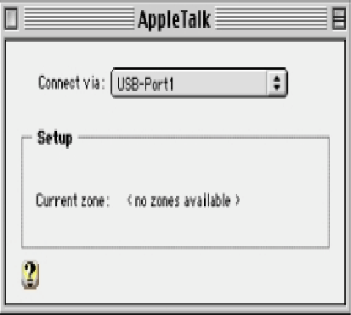

3. Close the AppleTalk dialog box and save the setting.
Access the shared files
1. Select Chooser from the system menu
2. Choose AppleShare icon.

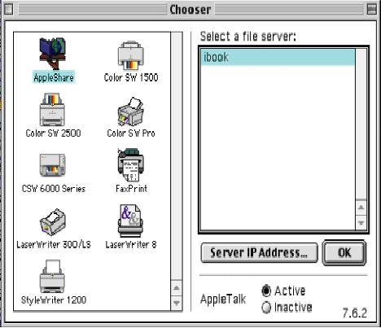
3. Select the computer to access from the file server list.
4. Choose login as Guest or Registered user. If choose to login as the registered user, enter the user name and password. The user name must have been created in the user list of the login file server.
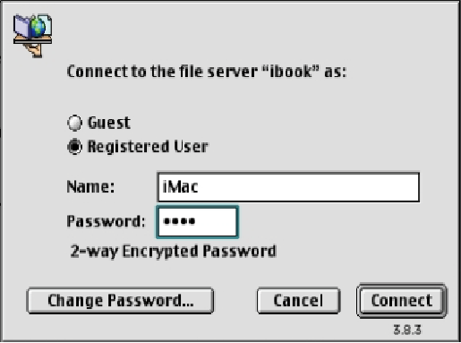
5. Press ‘Connect’ button.
6. Double click the file folder you want to access.

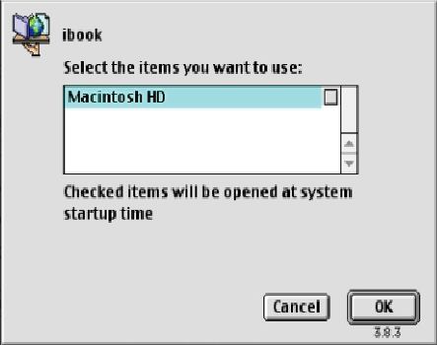

Internet sharing between PC and Macintosh
GeneLink supports the Macintosh to PC connection. To establish the network connection between Macintosh and PC, the same protocol must be installed on both computers. After the connection is established, PC can provide the Internet sharing service to Macintosh if the Windows software router is installed on PC. TCP/IP is the necessary protocol for Internet and is the common protocol for Macintosh and PC. However, Macintosh cannot provide the Internet sharing service to
PC since GeneLink doesn’t have the software router for Macintosh. GeneLink doesn’t support the native file sharing capability between Macintosh and PC.The file sharing service can be supported if the extra third party software is installed on Macintosh and PC.
Protocol setting for Macintosh
The TCP/IP setup procedure in Mac is described as follows.
1. Select ‘Control Panels’ / ‘TCP/IP’ from the system menu.
2. Set the suitable TCP/IP parameters. Contact your system administrator if any problem in
TCP/IP setting.

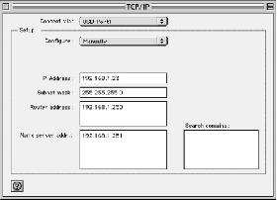

Protocol setting for PC
In PC side, GeneLink windows LAN driver is the necessary component for the GeneLink connection. To share the Internet resource with the other PC or Macintosh, the GeneLink software router needs to be installed. Please run the GeneLink windows driver setup program and set the suitable TCP/IP value for the Internet connection.
Macintosh can connect to Internet when the TCP/IP setting on both PC and Macintosh are correct. The Macintosh users can then use the Internet explore or ftp through GeneLink.

