GeneLinkTM User Guide

Installing USB TO Network Cable :
Follow the steps below on installing the USB TO Network Cable software:
- Power on your computer and make sure that the USB port is enabled and working properly.
2. Please double click "setup.exe" to get " image 1 ".
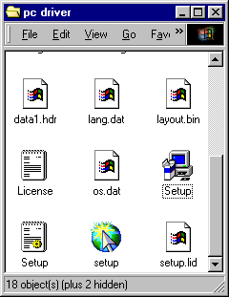

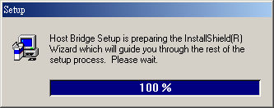
image 1

3. Please click " Next " continue to install.
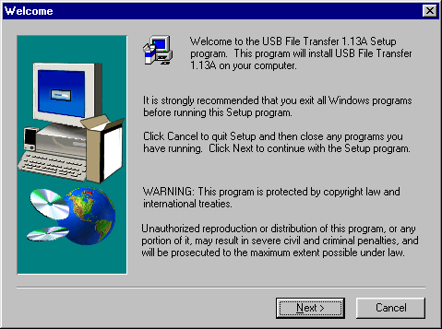
4. Please click " Yes" to continue installing.
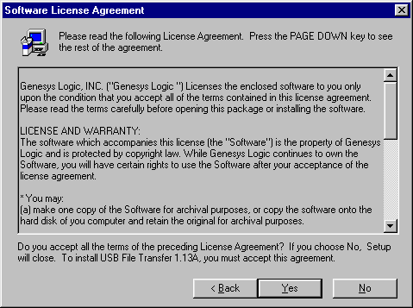

5. If it's installed to a different folder, Please click Browse and select another folder. Then click
" Next " to continue installing.
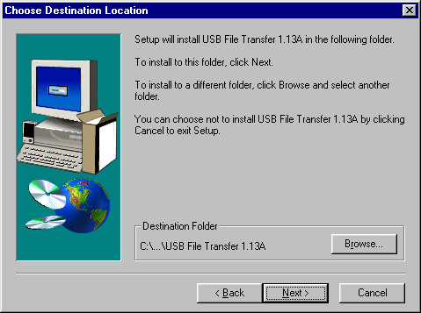
6. After windows copy the needed files to the system, it will get the following interface. Then, Please
connect the USB Link Cable to the USB PORT of the computer, And click " Finish " It's will install the USB Link Cable automatic.
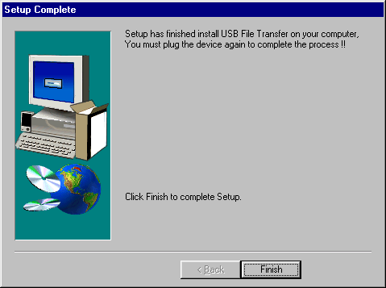

7. It will show following icon .
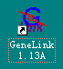
8. Move the course on “My Computer” icon as below. Double-click the icon to open “My
Computer”, you will see “ Removable ”; and then click the right button of mouse and a pull-down window appears. Select the latest item-“Properties”.
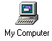
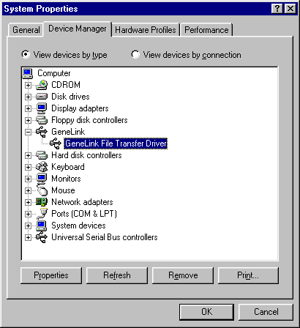

application in practice:
- Please double click "GeneLink 1.13A" which on the desk up to get "image 2 " .
- It means having not been connected. (Image 2)
- It means being on connection. (Image 3)
- It means being connected. Meanwhile, the " Remote Desktop " on the right will display the other
computer’s catalogue. (image 4 )
- Select the folder & file which should be copy, then click or or to copy the folder & file to the corresponding computer.

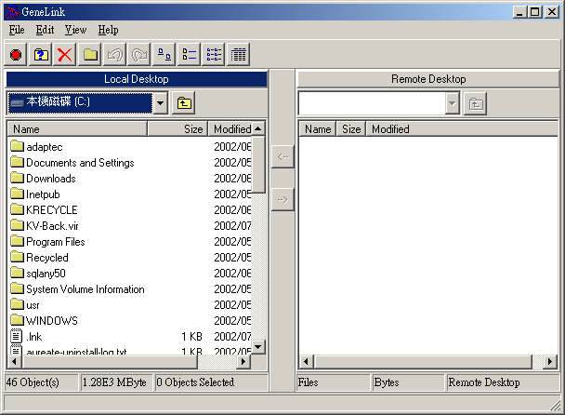
1
image 2
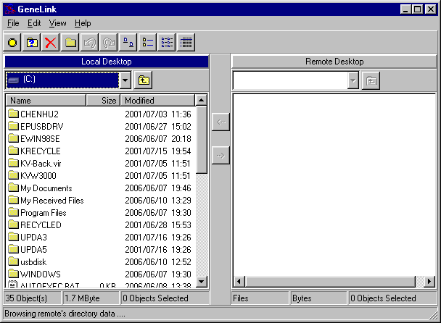
2
image 3
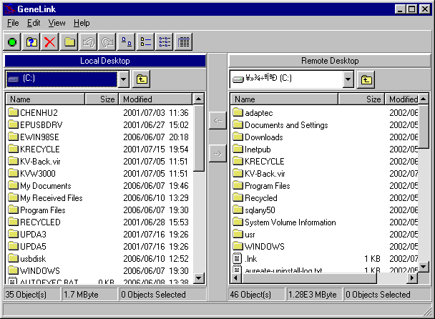
3
image 4
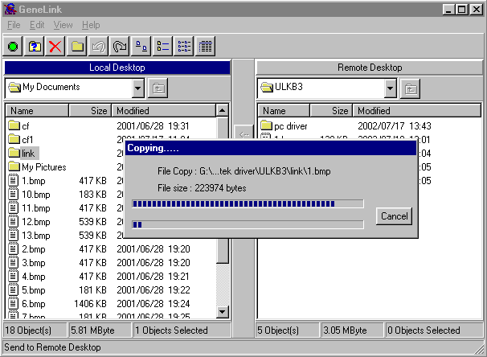

image 5
Remove USB TO Network Cable

- Firstly, Please pull out the USB Link Cable from the USB Port .
- Please open the " Control Panel " ;Then double click " Add/Remove Programs " up to get Image 6 .
- Please select " USB File Transfer 1.13A" , and click " Add/Remove " on the right . Then remove USB Link Cable .

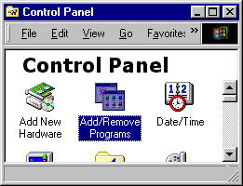
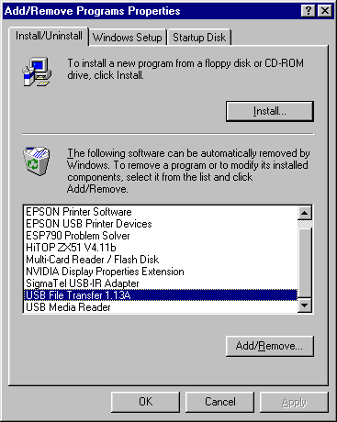
image 6

