USB SM Card Reader
User’s Manual
- Introduction
- Product Features
- System Requirements
- Installing USB SM Card Reader
- Remove USB SM Card Reader

1. Introduction

Travel Flash Series are the only Readers/Writers in the world. You can store your data in the Travel Flash readers/writers anytime, anywhere even without any Flash Card on hand.Travel Flash readers/writers offer the most convenient method to move and store the music, images and data.
2. Product Features
※ Hot-Swappable Supported, Compliant to USB 1.1
※ Flash Card Support : Smart Media Card
※ Easy to carry in your pocket
※ support Windows 98, 98SE, 2000, ME, and XP, and Mac 8.6 or above.
※ Only window 98,98SE need driver
3. System Requirements

- IBM PC or compatible PC with 486DX-100 MHz CPU or higher
- Available USB port
- CD-ROM drive
- At least 16MB of DRAM

4. Installing USB SM Card Reader:
Follow the steps below on installing the USB SM Card Reader software:
1.Power on your computer and make sure that the USB port is enabled and working properly.
2. Please do not connected the USB SM Card Reader with the computer when you it's on installing .
3. Please double click " setup.exe, then it's will get the installation interface .
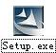
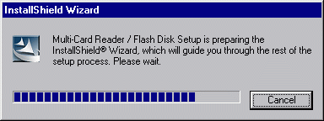

4. Click ‘Next’.

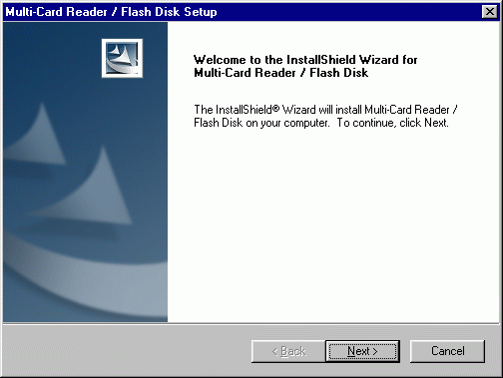

5. Click ‘Next’ .

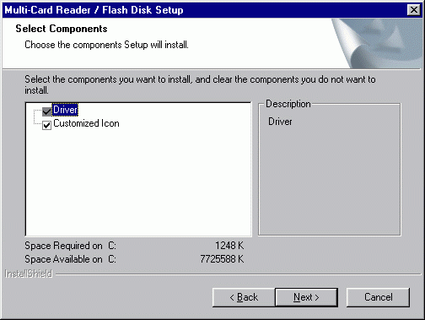

6. Let Windows copy the needed files to your hard disk.

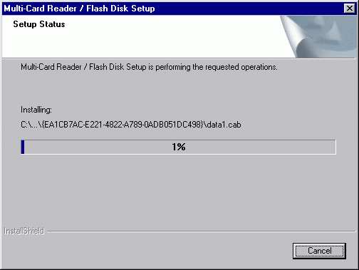

7. Installation was finished.. Click " Finish " and restart computer.

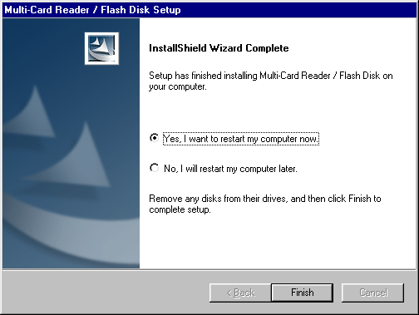

8. After restart the computer, please connected the USB SM Card Reader with USB Port of the Computer , It's will checking & installing automatic (If it's your first time to install it, The computer will get a reminder " You need the install disk of Windows 98 " .
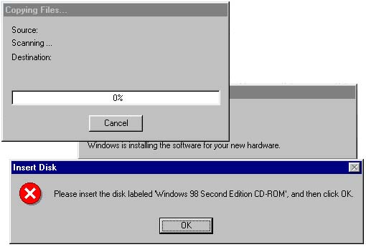

9. Installation was finished.. You can find "Multi-Card Reader 6 in 1 " & "USB Mass Storage disk Driver " following the route of : System Properties / Device Manager /Universal Serial Bus Controllers " . When you see the Single " Removable Disk " from "my computer “. Congratulation!! You are successful.
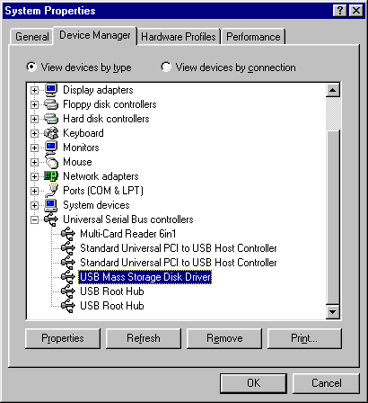
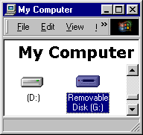

5. Remove USB SM Card Reader :

- Firstly, Pull out the USB SM Card Reader from the USB PORT.
- And then, double-click ”Add/Remove Programs Properties” in the “control panel” , select ” Multi-Card Reader/Flash Disk ” in the ”Install/Uninstall”, Click the below of right corner ”Add/Remove”.

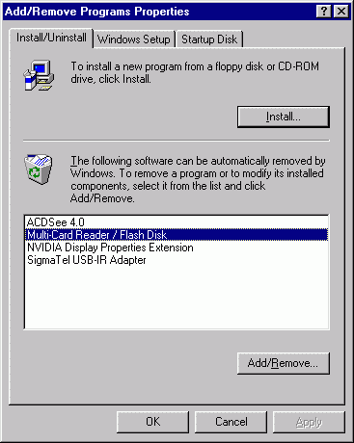
3. Select “Remove”, and then Click “Next”.
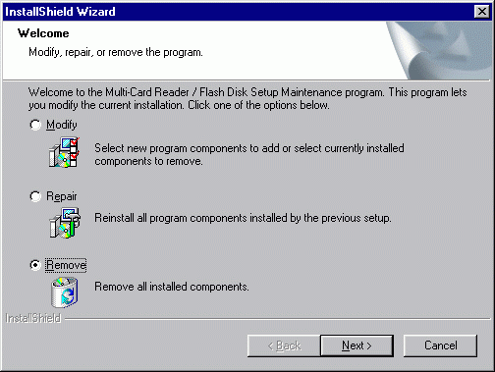
4. Click “ok”.

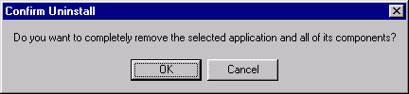
5. Click “Finish”, restart the computer. Was Finished remove.
