USB Ethernet 10/100 Adapter
User’s Manual

1. Introduction
The USB Ethernet 10/100 adapter performs good plug and play connection of PC peripherals
“out -side the box” and mark a significant advance in desktop cable management . Using the USB
Ethernet 10/100 adapter you can simplify your PC network connections in the home , office and
on the travel.
2. Product Features
- Realtek chipset.
- USB specification Ver. 1.0 and1.1 compliant.
- IEEE 802.3 MII compliant.
- Supports USB Suspend/Resume Function.
- Full-Speed USB Device.
- Supports wakeup frame, link status change and magic packet wake-up .
- Supports win98/2000/ME/XP
- Supports plug and play.
3. System Requirements
- IBM PC or compatible PC with 486DX-100 MHz CPU or higher
- Available USB port
- CD-ROM drive
- At least 16MB of DRAM
- Windows 98/2000/ME/XP
4. InstallING USB Ethernet 10/100 adapter:
Follow the steps below on installing the USB Ethernet 10/100 adapter software:
- Power on your computer and make sure that the USB port is enabled and working properly.
- Plug in the Realtek RTL8150 USB 10/100 Fast Ethernet adapter into the USB port, there appears a windows about ”New Hardware Found” on the desktop.

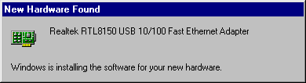

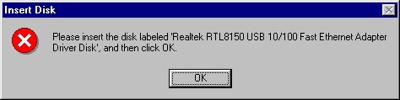
- following, there appears a windows about ”Insert Disk” on the desktop and then click “OK “ to continue.

- Insert the Realtek RTL8150 USB 10/100 Fast Ethernet adapter compact disc into the CD Rom drive and choose “UBRJ4\win98”,Click “Next” to continue.

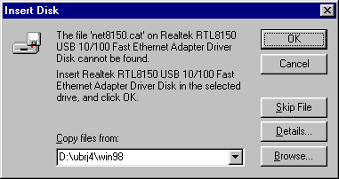

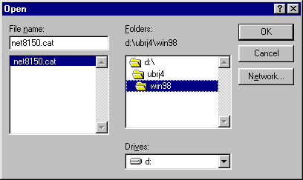

- And then ,System will automatic install the driver Realtek RTL8150 USB 10/100 Fast Ethernet Adapter的driver.
- After finished the installation will see ”Realtek RTL8150 USB 10/100 Fast Ethernet Adapter” under ”Network adapters” of ”System Properties”.

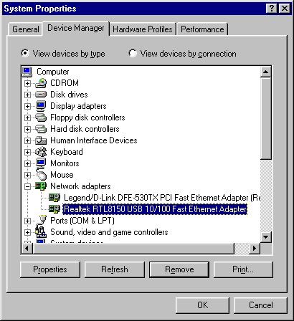

5. For Example

- If you use inner network,the server is Windows NT,Please set a servers domain name for “Workgroup”(for instance: domain2);And the ”Computer name” must differ the other computer,you can needn’t set ”Computer Description”.

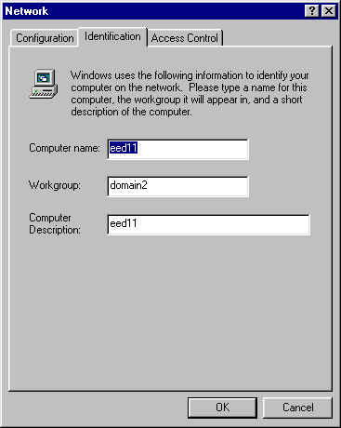

2. In ”Configuration”,you must install the protocol for NetBEUI and TCP/IP.

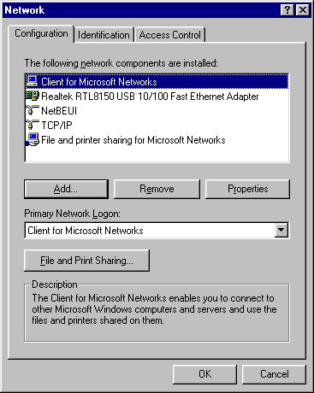

3. Under ”Client for Microsoft Networks Properties”,choose ”Log on to Windows NT domain”,under ”Windows NT domain” input domain name of inner network(for instance:Domain2).Here,you computer has entered the inner network you may use the data of inner network.

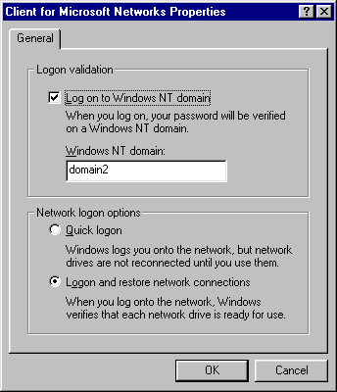

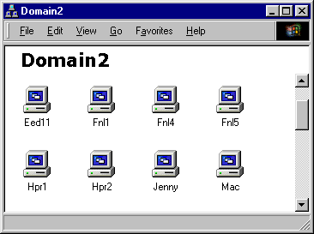

4. If your inner network can visit Internet,setup the protocol of “TCP/IP”,you may look for the information in internet.
At first,set up the IP Address:
You must obey the regulation ”IP address”.
for instance:

server of ”IP address” : 192.168.100.1
inner network of increase by degrees of ”IP address” : 192.168.100.2 ~192.168.100.255
” Subnet Mask” of and the other computer: 255.255.255.0
”New gateway” of and the other computer: 192.168.100.1

