Installation Guide of Genesys Logic USB2LPT Cable
1. Overview
2. Install for the first time
3. Uninstall Driver
4. Caution – Bidirectional Problem

Overview
The installation procedure of Genesys Logic USB2LPT cable is easy and fast, please follow the instructions of the section entitled “Install for the first time”.
If there is necessary to re-install the driver , you have to remove the old installation before the re-installation, please follow the instructions of the section entitled “Uninstall Driver” to remove Genesys Logic USB2LPT driver from your PC.

Install for the first time
1.Plug your USB2LPT cable to PC, don’t connect the USB2LPT cable with the printer in the mean time. Win98 will show an “Unknown Devices” message box as below.
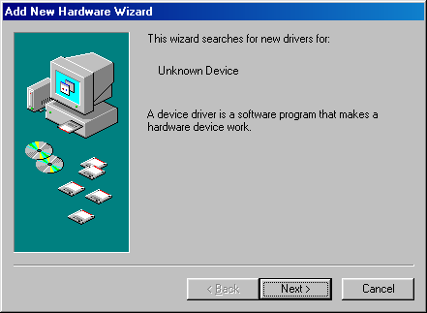
2.Select “Search for the best driver for your device”.
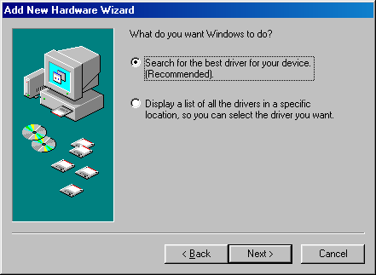
3. Insert the Genesys Logic USB2LPT install disk to your floppy drives. Click “Floppy disk drives”, the install wizard of win98 will copy necessary driver files to the hard disk. Then the Genesys Logic USB2LPT port is successfully installed on your PC.

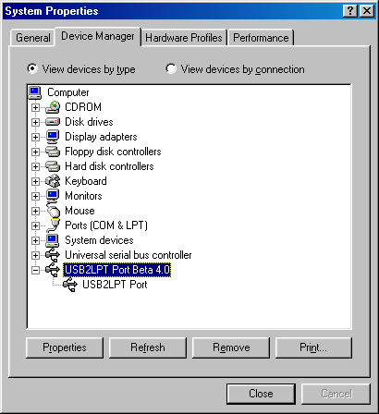
5.Connect the USB2LPT cable to your printer, then power on your printer.
6. If your printer driver is already installed, please change the printer port to the USB2LPT port. Or you have to install the printer driver, then change printer port to the USB2LPT port.
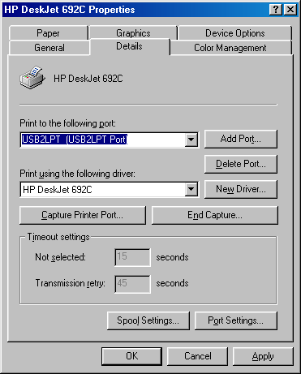

Uninstall Driver
Run delusb.exe. It will clean your old installed driver. It will delete the driver files in your hard disk and remove the associate keys in the registery. And more importantly, if there is any printer that use our USB2LPT port, it will change the connecting port to LPT1 automatically. Please change the connecting port of your printer if you don’t want to use LPT1.
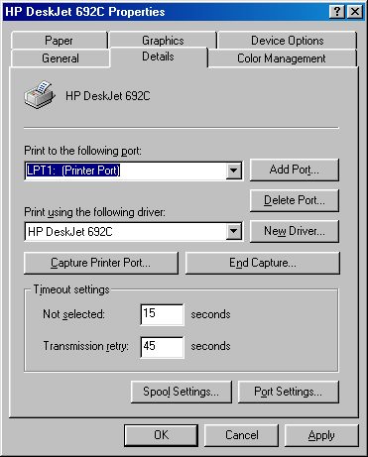

Caution – Bidirectional Problem
For some advance printer, there is an option for bi-directional communication support, such as HP DeskJet 720C.The Genesys Logic USB2LPT cable doesn’t support bi-directional communication, please do the following steps to disable printer bi-directional support.
[Start] ->[Setting]->[Printer]->Select your printer with mouse->Click the right button to select properity->[Details]->[Spool Settings]->[Disable bi-directional support for this printer]
