USB TO PDA Palm V
User Guide

Driver Installation (WIN2000)
Follow the steps below to install Window 2000 driver of USB TO PDA Palm V:
- Power on your computer and make sure that the USB port is enabled and working properly.

- Plug in the USB TO PDA Palm V into the USB port and run the Found New Hardware Wizard to assist you in setting up the new device. Click Next to continue.

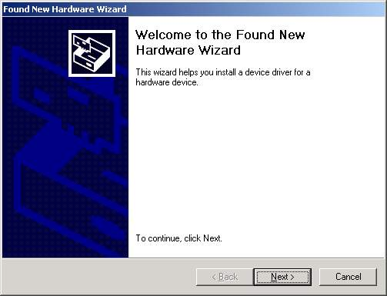
- Insert the USB TO PDA Palm V software driver into the CD-ROM drive and click Next to continue. For Windows 98, click Search for a suitable driver for my device(recommand) and click to search driver from the CD-ROM drive D:\ USB 1.1 TO PDA PALM V \Win2K. (D: represents CD-ROM)

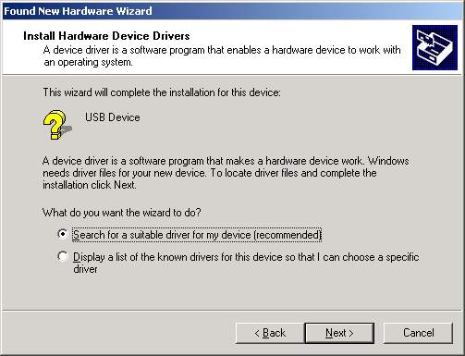

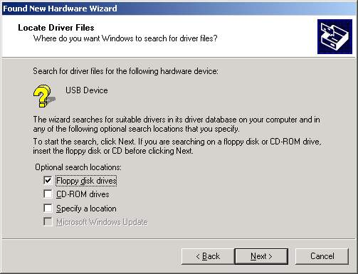

- Windows will detect the driver and Click Next to continue installation.
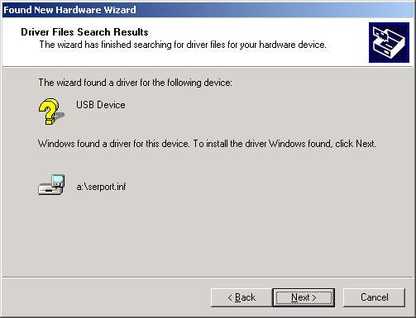
- Click Finish to continue and let Windows copy the needed files to your hard disk.

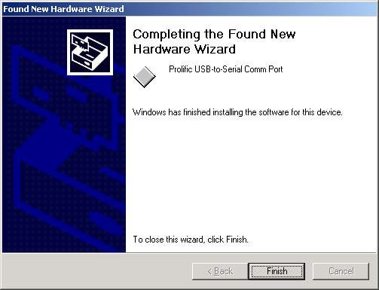

- You can to check the Device Manager and see the Prolific USB to Serial Comm Port)

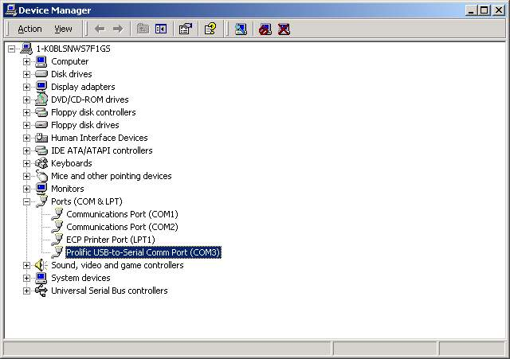.

Uninstalling the Driver Program
If you want to remove the USB TO PDA Palm V driver program, you can uninstall it by following the steps below:
- Unplug the USB TO PDA Palm V from your PC.
- Run the D:\ USB 1.1 TO PDA PALM V \Win2K\DRemover2K.EXE program from the software CD-ROM, then reboot the PC.
