USB TO PDA PALM V
User’s Guide
Driver Installation (WIN98&ME)
Follow the steps below to install Window 98 or Window ME driver of USB TO PDA PALM V:
- Power on your computer and make sure that the USB port is enabled and working properly.

- Plug in the USB TO PDA PALM V into the USB port and run the Add New Hardware Wizard to assist you in setting up the new device. Click Next to continue.

- Insert the USB TO PDA PALM V software driver into the CD-ROM drive and click Next to continue and click to search driver from the CD-ROM drive D:\ USB 1.1 TO PDA PALM V \Win98_ME. (D: represents CD-ROM)

- Windows will detect the driver and shows the USB to Serial Cable. Click Next to continue installation.

- Click Next to continue and let Windows copy the needed files to your hard disk.

- When Windows finished installing the software,click Finish.

- See the Device Manager to check the USB to Serial Cable.
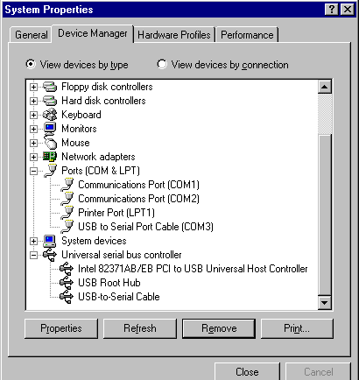

Uninstalling the Driver Program
If you want to remove the USB TO PDA PALM V driver program, you can uninstall it by following the steps below:
- Unplug the USB TO PDA PALM V from your PC.

- Run the D:\ USB 1.1 TO PDA PALM V WIN98_ME\ DRemover98_Me.exe program from the software CD-ROM, then reboot the PC.
