User’s Manual
USB TO PDA Palm V
MAC DRIVER

Driver Installation
Follow the steps below to install driver of USB TO PDA Palm V:
- Power on your computer and make sure that the USB port is enabled and working properly.
- Insert the USB TO PDA Palm V software driver into the CD-ROM drive.

- Plug in the USB TO PDA Palm V into the USB port and run the pl2303.SIT from the CD-ROM,it will auto run the program and appear a PL-2303 system extentions.
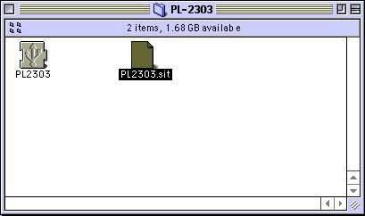
- Copy the PL-2303 system extensions to the system Folder-Extensions.
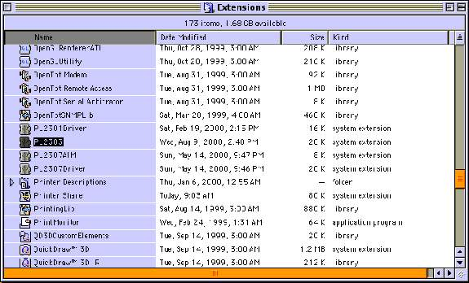
4.To make sure that your computer can use the device correctly, you have to check the Apple System Profiler-Device and Volumes.It will show the USB Device.
