USB TO PDA Palm III
User Guide

Driver Installation (WIN2000)
Follow the steps below to install Window 2000 driver of USB TO PDA Palm III:
- Power on your computer and make sure that the USB port is enabled and working properly.

- Plug in the USB TO PDA PALM III into the USB port and run the Found New Hardware Wizard to assist you in setting up the new device. Click Next to continue.

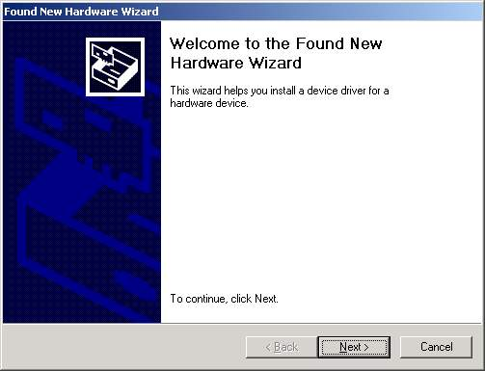
- Insert the USB TO PDA PALM III software driver into the CD-ROM drive and click Next to continue. For Windows 98, click Search for a suitable driver for my device(recommand) and click to search driver from the CD-ROM drive D:\ USB 1.1 TO PDA PALM III \Win2K. (D: represents CD-ROM)

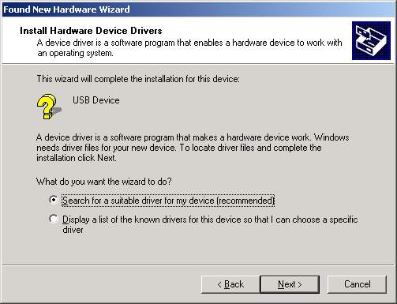

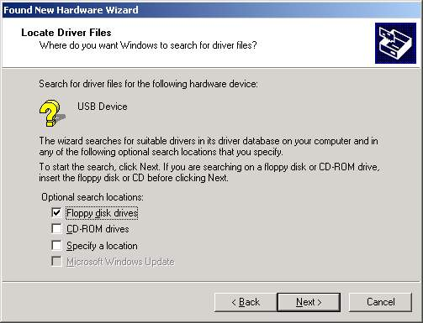

- Windows will detect the driver and Click Next to continue installation.
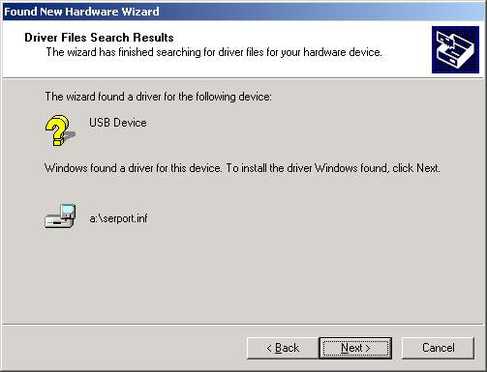
- Click Finish to continue and let Windows copy the needed files to your hard disk.

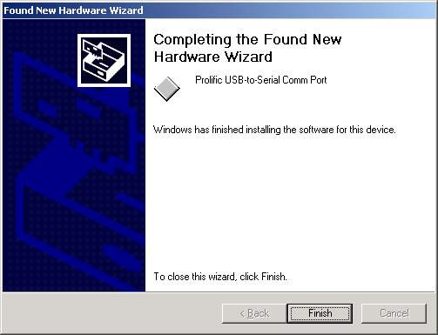

- You can to check the Device Manager and see the Prolific USB to Serial Comm Port)

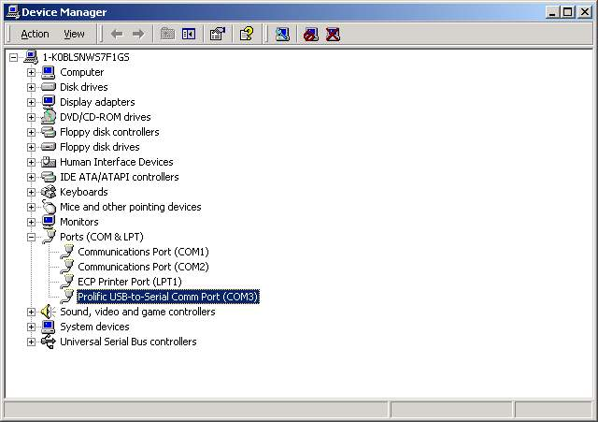.

Uninstalling the Driver Program
If you want to remove the USB TO PDA PALM III driver program, you can uninstall it by following the steps below:
- Unplug the USB TO PDA PALM III from your PC.
- Run the D:\ USB 1.1 TO PDA PALM III \Win2K\DRemover2K.EXE program from the software CD-ROM, then reboot the PC.
