USB TO PDA PALM III
User’s Guide
Driver Installation (WIN98&ME)
Follow the steps below to install Window 98 or Window ME driver of USB TO PDA PALM III:
- Power on your computer and make sure that the USB port is enabled and working properly.

- Plug in the USB TO PDA PALM III into the USB port and run the Add New Hardware Wizard to assist you in setting up the new device. Click Next to continue.

- Insert the USB TO PDA PALM III software driver into the CD-ROM drive and click Next to continue and click to search driver from the CD-ROM drive D:\ USB 1.1 TO PDA PALM III \Win98_ME. (D: represents CD-ROM)

- Windows will detect the driver and shows the USB to Serial Cable. Click Next to continue installation.

- Click Next to continue and let Windows copy the needed files to your hard disk.

- When Windows finished installing the software,click Finish.

- See the Device Manager to check the USB to Serial Cable.
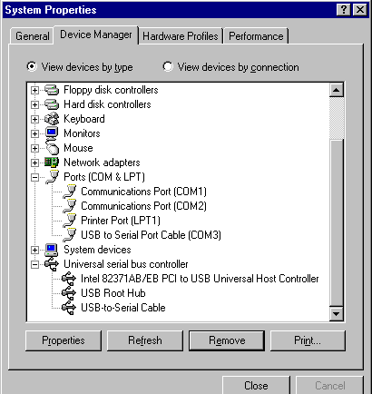

Uninstalling the Driver Program
If you want to remove the USB TO PDA PALM III driver program, you can uninstall it by following the steps below:
- Unplug the USB TO PDA PALM III from your PC.

- Run the D:\ USB 1.1 TO PDA PALM III WIN98_ME\ DRemover98_Me.exe program from the software CD-ROM, then reboot the PC.
