USB-Serial Adapter
User Guide
1. Product Features
2. System Requirements
3. Driver Installation (WIN2000)
4. Setting Up the RS232 Serial Device
5. Uninstalling the Driver Program

Product Features
- USB Specification Rev. 1.1 compliant
- Support the RS232 Serial interface
- Over 1Mbps data transfer rate
- Support remote wake-up and power management
System Requirements
- IBM PC 486DX4-100 MHz CPU or higher or compatible system
- Available USB port
- CD-ROM drive
- Windows 2000
Driver Installation (WIN2000)
Follow the steps below to install Window 2000 driver of USB-Serial cable:
- Power on your computer and make sure that the USB port is enabled and working properly.

- Plug in the USB-Serial cable into the USB port and run the Found New Hardware Wizard to assist you in setting up the new device. Click Next to continue.

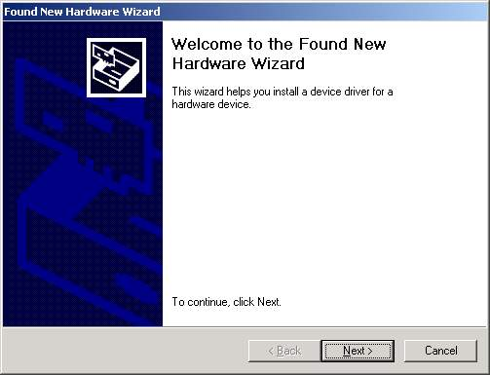
- Insert the USB-Serial cable software driver into the CD-ROM drive and click Next to continue. For Windows 98, click Search for a suitable driver for my device(recommand) and click to search driver from the CD-ROM drive D:\un8be\Win2000. (D: represents CD-ROM)

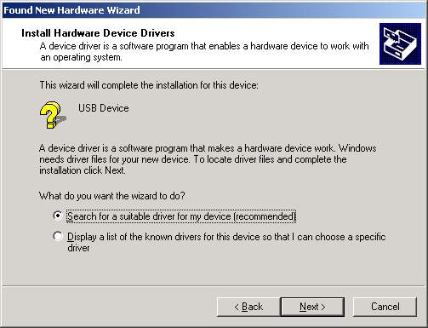

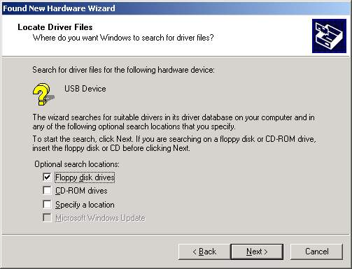

- Windows will detect the driver and Click Next to continue installation.
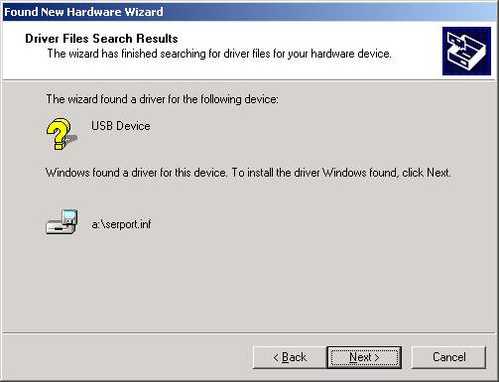
- Click Finish to continue and let Windows copy the needed files to your hard disk.

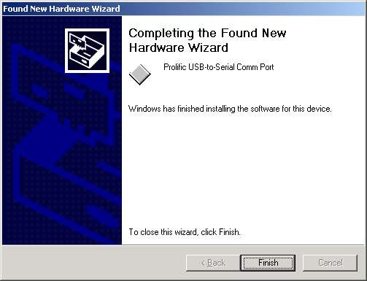

- You can to check the Device Manager and see the Prolific USB to Serial Comm Port)

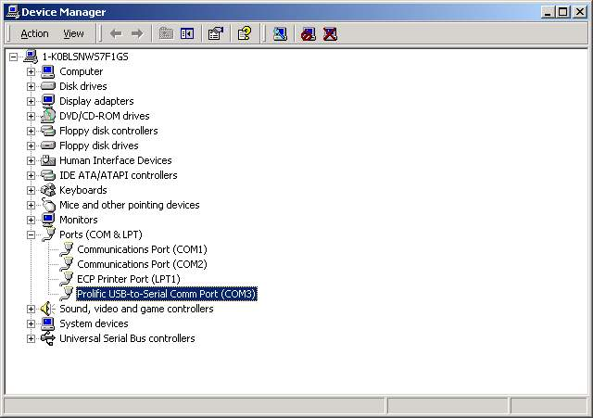.
Setting Up the RS232 Serial Device
Follow the steps below to connect your RS232 Serial Device (ie: Modem) to the USB port of your PC:

- Turn off your Modem. Plug the DB 9 connector of the USB-Serial cable into your Modem. Turn on the Modem afterwards.
- Turn on your computer and plug in the USB connector of the USB-Serial cable into the USB port.
- If you have already installed a Modem device before, click Start, Settings, Modems. Open Modems Properties, select the Modem, click Properties. In General tab, please change the Port value to USB to Serial Port (COM3).
- After finishing these processes, you can use USB to Serial Bridge Cable to connect RS232 Serial 56K FAX Modem and execute the Dial-up fuction to connect Internet, and send the FAX with the FAX software(ie: Microsoft FAX) properly.

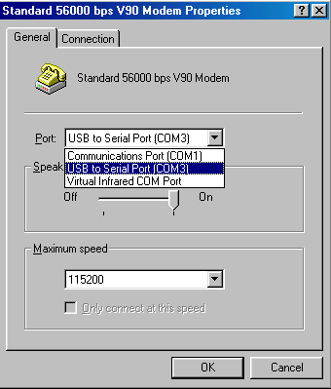

Uninstalling the Driver Program
If you want to remove the USB-Serial cable driver program, you can uninstall it by following the steps below:
- Unplug the USB-Serial cable from your PC.
- Run the D:\un8be\Win2000\UNINSTALL.EXE program from the software CD-ROM, then reboot the PC.
