USB 2.0 6 IN 1 Card Reader
User’s Manual

- Introduction
- Product Features
- System Requirements
- Installing USB 6 in 1 Card Reader
- Safely Exit USB 2.0 6 in 1 Card Reader
- Remove USB 6 in 1 Card Reader

1. Introduction
This 6 in 1 combo PC Card Reader is a powerful & multi-functional device among all the other available drives, for it’s able to access most of the flash cards including : Compact Flash﹑Micro Drive﹑Secure Digital﹑Smart Media﹑Memory Stick﹑Multi Media.

2. Product Features
Hot-Swappable Supported , compliant to USB 2.0
Flash Card Support: Compact Flash Card/Micro Drive/Smart Media
Card/Multimedia Card/Secure Digital Card/Memory Stick Card
Read and write Compact Flash Card/Micro Drive/Smart Media
Card/Multimedia Card/Secure Digital Card/Memory Stick Card
Built-in Flash Capacity(Optional,16MB~128MB)
Support WIN98/2000/XP Mac os V8.6 or higher

3. System Requirements
IBM PC or compatible PC with 486DX-100 MHz CPU or higher
Available USB port
CD-ROM drive
At least 16MB of DRAM

4. Installing USB 6 in 1 Card Reader:
Follow the steps below on installing the USB 6 in 1 Card Reader software:
1. Power on your computer and make sure that the USB port is enabled and working properly.
2. Please do not connect the USB 6 in 1 Card Reader with the computer when you it's on installing.
3. Please double click and open the folder “USB 2.0 6 IN 1 CARD READER” in the CD-ROM.

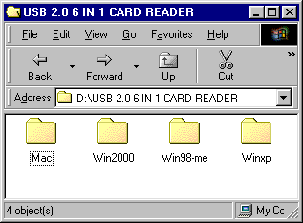

- Please double click and open the folder “ Win98-me ”

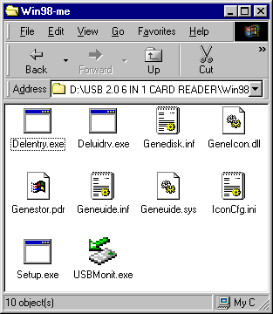

- Please double click” Setup”.Windows will copy the needed files to your hard disk .There will appear a following dialog box while finished.

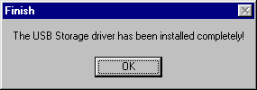

6. At this time ,please plug the USB 2.0 6 IN 1 Card Reader into your computer .Windows will detect and install it automatically .When finished ,you can see four disk icons in “My Computer ” as below.

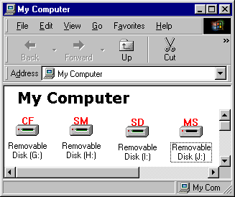

- Follow the steps :right click “My Computer” at desktop ,appear a pup-up menu, select “Properties”, display “System Properties”, click “Device Manager”, you can see “ USB Card Reader ”in “Universal Serial Bus controllers ”of “Device Manager ”and four “Generic STORAGE DEVICE ”in “ Disk Drives ”of “Device Manager ”.Thus, it mean you install the USB 2.0 6 in 1 Card Reader successfully .

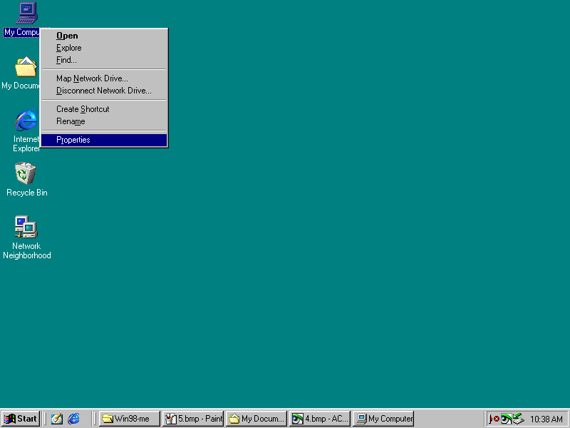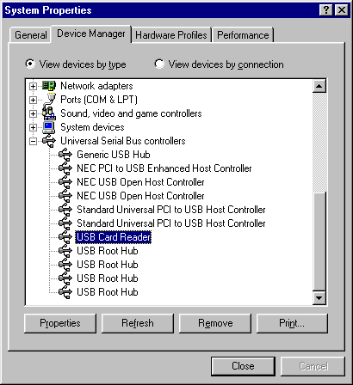

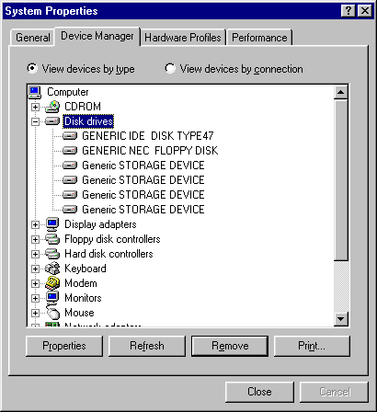

5. Safely Exit USB 2.0 6 in 1 Card Reader

If you didn’t find an arrowheaded icon at right corner in system status bar, please double click “USBMonit” in the folder “Win98-me”, there will appear an arrowheaded icon at right corner in system status bar. When you want to unplug the USB 2.0 6 in 1 Card Reader from your computer, please right click the icon and click “Stop USB Card Reader ”,then you can unplug it .


Arrowheaded icon
Double click

click
Right click

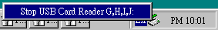

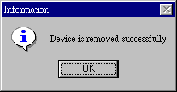

- Remove USB 2.0 6 in 1 Card Reader :

1. Please double click “deluidrv.exe” in the folder “Win98-me”.
Double click

- There will appear a dialog as below, please click “Yes”.

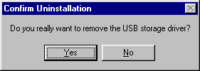

- When the following dialog box displayed, it mean you have uninstalled the USB 2.0 6 in 1 Card Reader driver successfully.

