USB 2.0 Network Cable
User’s Manual

- Overview
- Product Features
- Install The USB 2.0 Network Cable Driver
- Sharing In Your Resource PC To PC
- Uninstall The USB 2.0 Network Cable Driver

1. Overview
The USB 2.0 network cable provides the easiest network cable. Two PCs can transmit data each other through the USB 2.0 network cable without any network adapter else.

2. Product Features:

Two PCs can transmit data each other through the USB 2.0 network cable:

USB2.0 network cable
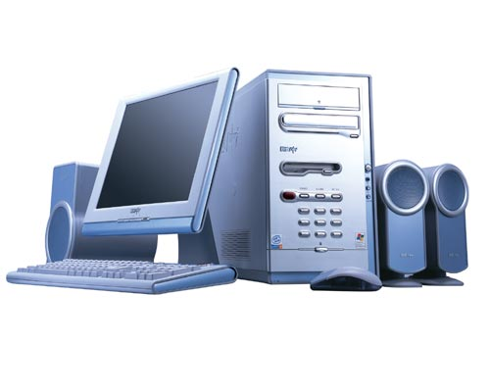

PC

PC

3. Install The USB 2.0 Network Cable Driver:

1. Please follow the steps as below to install the USB 2.0 network cable driver:
2. Power on your computer, make sure that the USB port enable and work properly.
3. Double click and open the folder ”USB 2.0 NETWORK CABLE”, double click “Setup.exe”
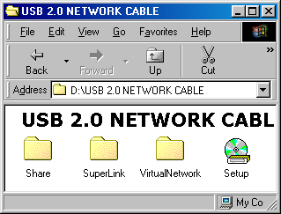
4. There will appear a dialog box as below, Please specify the language during installation：1. English 2. Japanese 3. Chinese(Traditional) 4. Chinese(Simplified) , please choose 3. Chinese(Traditional)，then click“Next”to continue.

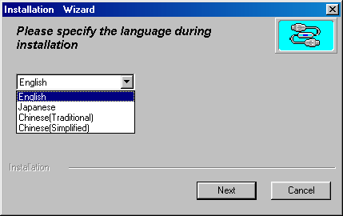
5. Please choose the installation type : 1. USB Super Link Adapter 2. USB Virtual Network Adapter, please choose 1. USB Super Link Adapter , then click “Next” to continue.
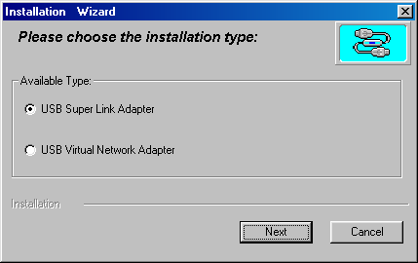
6. There will appear a dialog box as below, please click“Next”to continue.
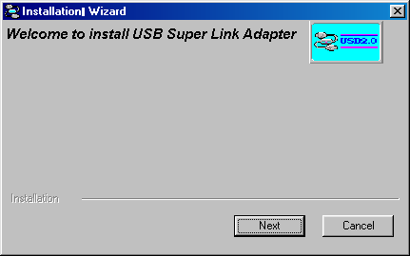

7. There will appear a windows as below, if you want to change the installation directory, please click “change directory” then click “Next” to continue.
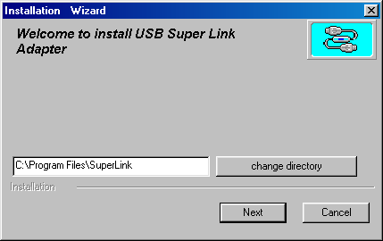
8. There will appear a dialog box as below, windows have already copied the needful driver files to your computer.
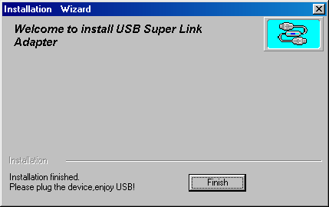
9. When finished, there will show an icon at desktop as below:
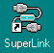
10. Please plug the USB2.0 network cable into your computer, windows will detect and install it automatically. Follow the steps “System Properties”->“Device Manager”->“Universal Serial Bus controllers”, you can see “USB Super Link Adapter”, it means that you are successful.
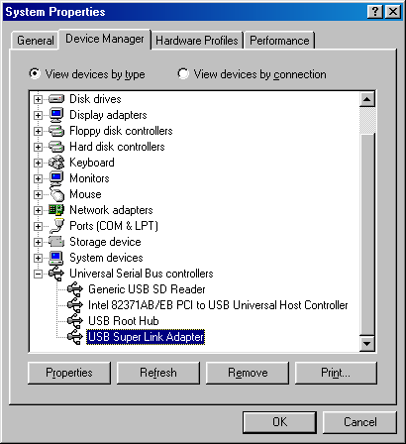

4. Sharing In Your Resource PC To PC

- Please double click the icon as below in two PCs at the same time.
- There will appear a window as below:
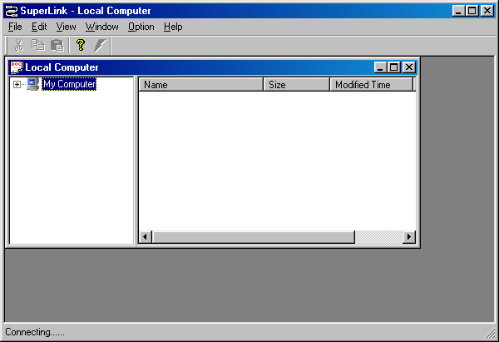
Notes:
There will show current state at left corner of the status bar(Connecting…). It is on connecting to the other computer…
3. When connected successfully, a window will appear as below
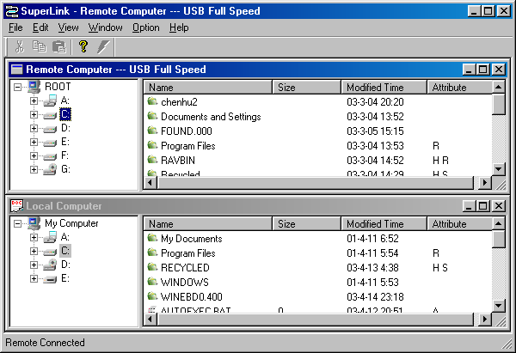
Notes:
(1). There will show current state at left corner of the status bar(Remote Connected）It has already connected with the other computer.
(2). In the window above, you also can see all the logic disks of the two computers.
(3). You can use it as windows explorer. You can operate the files or folders such as Cut、Delete、Copy、Paste、New Folder、Select All ,etc.
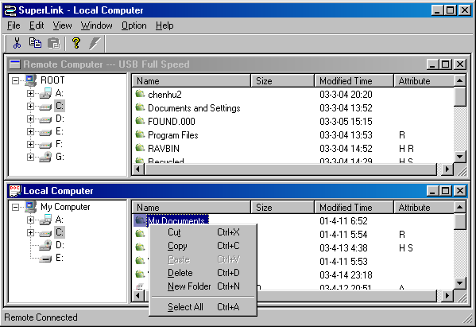
- You can select the files or folders that you want to copy, then use mouse to drag them into the other computer.
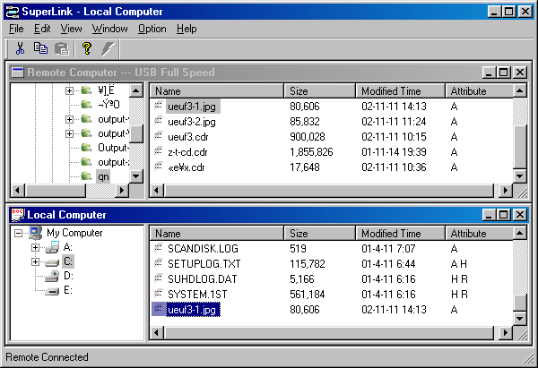
Drag this file into the other computer

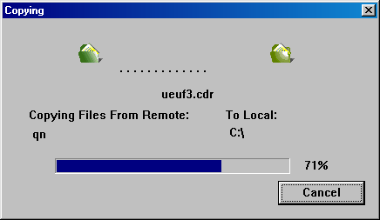
5. Uninstall The USB 2.0 Network Cable Driver
Please unplug the USB 2.0 network cable from the port of your computer!
- Please follow the steps “Start”-> “Programs”->“USB SuperLink”, click “Setup.exe”
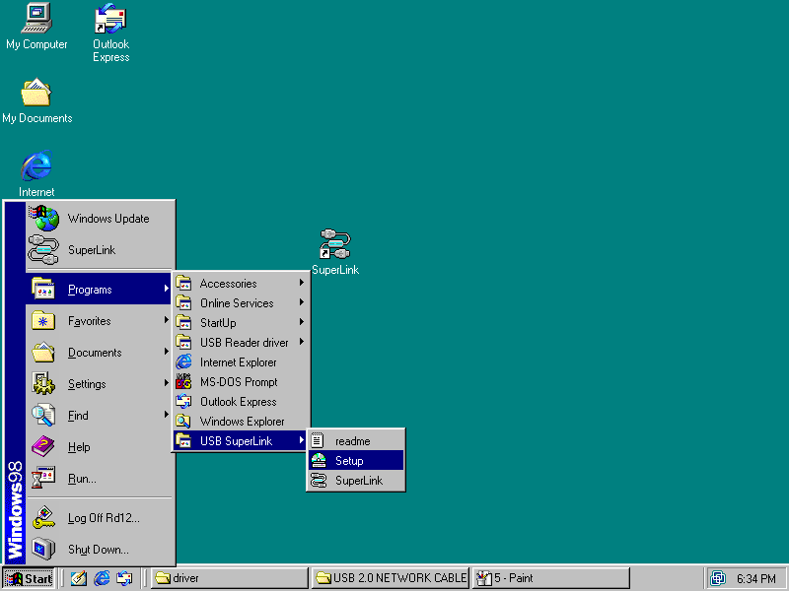
Click it
2. There will appear a dialog as below, please specify the language during installation：1. English 2. Japanese 3. Chinese(Traditional) 4. Chinese(Simplified) , please choose3. Chinese(Traditional)，then click “Next” to continue.
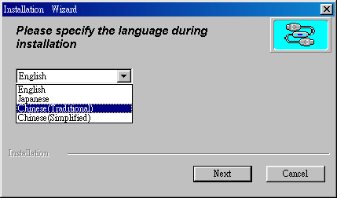

3. Please choose the installation type： 1. USB Super Link Adapter 2. USB Virtual Network Adapter, please choose 1. USB Super Link Adapter , then click “Next” to continue.
4. Please select the second item “Only remove USB Super Link Adapter driver”, click “Next” to start to uninstall the USB2.0 network cable driver.
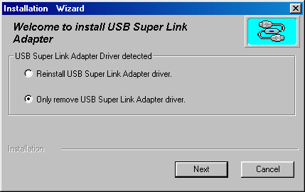
5. Click “Finish”, uninstall completely.

